Mansion Energy Forecast

Waseem Pasha
Juha Holmstedt
Sanjida Provati
Abdullah Wasim

Group Work
December 2025
Master’s Degree Programme in Artificial Intelligence and Data Analytics

Waseem Pasha Juha Holmstedt Sanjida Provati Abdullah Wasim
Mansion Energy Forecast
Jyväskylä: Jamk University of Applied Sciences, December 2025, xx pages.
Master’s Degree Programme in Artificial Intelligence and Data Analytics
Permission for open access publication: Yes
Language of publication: English
Abstract

Keywords/tags (subjects)

Miscellaneous (Confidential information)
N/A
Contents
1 Data Cleaning & Preprocessing Documentation 4
1.1 Data overview 4
1.2 Cleaning decisions (what & why) 5
1.3 Exact processing flow (matches the shared notebook/script) 8
1.4 Added columns (data dictionary) 10
1.5 How teammates should use the cleaned file 11
1.6 Rationale behind key choices (short justifications) 12
1.7 Reproducibility & versioning 13
1.8 Limitations & notes 13
2 Data Cleaning and Feature Engineering 14
2.1 Introduction 14
2.2 Data Overview and Cleaning 14
2.3 Feature Engineering Process 15
2.3.1 Temporal Features 15
2.4 Weather-Derived Features 16
2.5 Lag Features (Short-term History) 17
2.6 Final Dataset and Export 19
2.7 Technical Challenges and Solutions 19
2.8 Sliding Window Preprocessing (preprocessing_windowing.py) 20
2.8.1 1. Train/Validation/Test Split 21
2.8.2 2. Feature Scaling 21
2.8.3 3. Windowed Sequence Creation 22
2.8.4 4. Saving Windowed Arrays 23
2.9 Summary and Conclusion of this step 24
2.10 Final output of this step: 24
2.11 What Do These. npy Files Contain? 25
3 Transformer-Based Model Implementation 26
3.1 Data Preprocessing and Feature Engineering 27
3.1.1 Time Indexing and Cleaning 27
3.1.2 Feature Scaling 27
3.1.3 Dataset Splitting 28
3.1.4 Windowed Dataset Creation 29
3.2 Model Implementation 30
3.2.1 Transformer Architecture Overview 30
3.2.2 One-Hour Ahead Model 30
3.2.3 Twenty-Four-Hour Ahead Model 31
3.2.4 Training Procedure 31
3.3 3.3 Results and Evaluation 32
3.3.1 3.3.1 One-Hour Ahead Forecasting Results 33
3.3.2 Twenty-Four-Hour Ahead Forecasting Results 35
3.4 3.4 Discussion 38
3.5 Conclusion 38
4 Gated Recurrent Unit (GRU) 39
4.1 Data Preparation 40
4.2 Model Training 42
4.3 Results 46
4.4 Observations 48
4.5 GRU for 24-Hour Ahead Multi-Step Forecasting 50
4.5.1 Model Structure 51
4.5.2 Training Behaviour 52
4.5.3 Results and Interpretation 52
4.5.4 Overall Assessment 56
5 Temporal Convolutional Network (TCN) 56
5.1 Data Preparation 57
5.2 Model Training (1-Hour Ahead TCN) 58
5.3 Results 58
5.4 Observations 61
5.5 TCN for 24-Hour Ahead Multi-Step Forecasting 61
References 65
Appendices 66
Appendix A. Code Snippets 66

Figures

Figures :
Figure 1. Training and validation loss for the one-hour Transformer model……………………6
Figure 2. Training and validation loss for the 24-hour Transformer model……………………...7
Figure 3. One-hour ahead prediction versus actual values for a selected 7-day period…...9
Figure 4. Predicted versus actual 24-hour consumption for a selected day…………………..10
Figure 5. Error by forecast horizon for the 24-hour model………………………………………….12

Table:
Table 1. Evaluation by Seasonal Windows………………………………………………………………..8
Table 2. Per-Horizon Error………………………………………………………………………………………11

Data Cleaning & Preprocessing Documentation
By creating a single, transparent data preprocessing pipeline, data leakage and temporal bias are prevented and all modeling approaches both neural and non-neural are trained on a uniform basis.
Hyndman and Athanasopoulos (2021) provided best practices for time-series data cleaning and feature preparation, and Wilcox (2012) provided principles for robust outlier treatment.
Chollet (2021) and Goodfellow, Bengio, and Courville (2016) provided preprocessing guidelines unique to neural networks.
This article provides a clear and repeatable explanation of how the raw hourly electricity dataset was preprocessed and cleaned so that each team member may train a different model (LSTM, GRU, TCN, Tree-based, Linear etc) using the same input. The guiding concepts were:
- One canonical dataset for the whole group (no per-model tweaks).
- Complete timeline (keep all hours, 2016–2022) to preserve seasonality.
- Model-agnostic choices (no feature engineering that privileges one model type).
- Transparency about data gaps: we flag missing weather instead of silently dropping/guessing.

Why this is important: time-series models are extremely vulnerable to uneven preprocessing, leakage, and missing timestamps. Keeping your evaluation trustworthy and avoiding apples-to-oranges comparisons are two benefits of establishing a single, consistent pipeline.

Data overview
Here is data overview –
Raw input: dataset_mansion.csv
- Hourly consumption: 2015-12-31 22:00 → 2022-05-31 20:00
- Hourly weather: 2017-01-01 → 2022-05-31
- Note: Hour t represents consumption between t-1 and t (per assignment).
Cleaned output: dataset_mansion_cleaned.csv
- Continuous hourly index (no gaps) from first to last timestamp found in raw.
- Kept full 2016–2022 period to support all modeling strategies.
- Weather gaps preserved via a flag (weather_missing) so modelers can include/exclude as they wish.

Cleaning decisions (what & why)
- Timestamp normalization & continuity
Electricity consumption data must have a consistent, evenly spaced timeline to preserve temporal relationships essential for forecasting.
- What:
  - Auto-detect the timestamp column (e.g., MTime), parse to datetime, sort, drop invalid rows.
  - Remove duplicate timestamps (keep the first).
  - Resample to hourly with .resample('H').asfreq() to enforce a complete hourly index.
- Why:
  - Neural and non-neural time-series models need a regularly spaced sequence.
  - Duplicates and ragged time grids cause silent leakage or unstable training.
2) Target (consumption) imputation
According to Hyndman and Athanasopoulos (2021), interpolation at short intervals (≤ 6 hours) is a widely used and experimentally validated technique for continuous sensor data.
This strikes a compromise between maintaining temporal continuity and little distorting underlying consumption patterns.
- What:
  - Convert to numeric; interpolate small gaps (≤ 6 hours) using time-based interpolation; then forward-fill/back-fill remaining gaps as a conservative fallback.
  - No deletion of rows to keep the time grid intact.
- Why:
  - Small gaps are common in sensor telemetry; time interpolation is stable for short spans.
  - For longer gaps, ffill/bfill preserves continuity without inventing unreal patterns.

- Weather handling & explicit missingness
Temperature, humidity, wind speed, and other meteorological factors are important indicators of household power demand, especially in regions where consumption patterns are dominated by heating and cooling loads.
However, irregular or missing weather observations might skew model training, therefore these deficiencies need to be addressed in a clear and methodical manner (Hyndman & Athanasopoulos, 2021).

- What:
  - Detect weather columns (temperature, humidity, precip, wind, pressure…).
  - Convert to numeric; same imputation rule as target: interpolate small gaps (≤ 6h), then ffill/bfill.
  - Crucially add weather_missing flag that marks hours where weather was originally absent (especially pre-2017). This is computed from the unresampled raw data aligned to the hourly grid; if a weather column didn’t exist, we conservatively mark pre-2017 as missing.
- Why:
  - Different teammates will use different models. Some may want to drop hours without real weather; others may keep them and let the model learn from the flag.
  - A binary missingness indicator is a standard, transparent approach to exogenous gaps.
4) Outlier treatment (winsorization)
As suggested by Wilcox (2012), winsorization clipping extreme values to the first and 99th percentiles was used to reduce the impact of severe spikes without eliminating data, preserving sequential integrity, which is essential for time-series models (Goodfellow et al., 2016).
- What:
  - Cut consumption to the 1st and 99th percentiles (winsorization).
- Why:
  - Rare spikes/outliers can dominate loss functions and destabilize training—especially for neural nets.
  - Without erasing data, winsorization maintains ordering and lessens excessive impact.
5) Light, model-agnostic time features
In line with feature engineering techniques in applied forecasting literature, seasonality modeling across algorithms is supported by using calendar-based features like hour-of-day and day-of-week (Hyndman & Athanasopoulos, 2021; Chollet, 2021).
- What:
  - Add hour, day-of-week, month, is_weekend, heating_season (Oct–Apr).
  - Provide optional cyclic encodings (hour_sin, hour_cos, doy_sin, doy_cos) widely useful across models.
- Why:
  - Without committing to intricate feature engineering that could skew the comparison, these are general calendar cues that many models benefit from.

Exact processing flow (matches the shared notebook/script)
- Load & inspect
  - Read CSV; detect time column; parse datetimes; drop rows with invalid times; set index; sort.
- Deduplicate & resample
  - Remove duplicate timestamps; resample to hourly (asfreq) to enforce a continuous grid.
- Column detection
  - Detect consumption column (common names or heuristics).
  - Detect weather columns by name patterns.
- Type conversion
  - Cast consumption & weather columns to numeric (errors='coerce').
- Weather missingness flag
  - Align original raw to hourly; for the first found weather column, mark NaN → 1 in weather_missing.
  - If not present, default to 1 before 2017-01-01 (documented).
- Imputation
  - Interpolate small gaps (≤ 6h) using time interpolation.
  - Then ffill/bfill for any remaining NaN.
  - Assert no NaN remains in consumption.
- Winsorize target
  - Clip consumption to [P1, P99] to reduce the influence of extreme spikes.
- Add time features
  - hour, dow, month, is_weekend, heating_season (+ optional cyclic encodings).
- Save
  - Write dataset_mansion_cleaned.csv for shared use.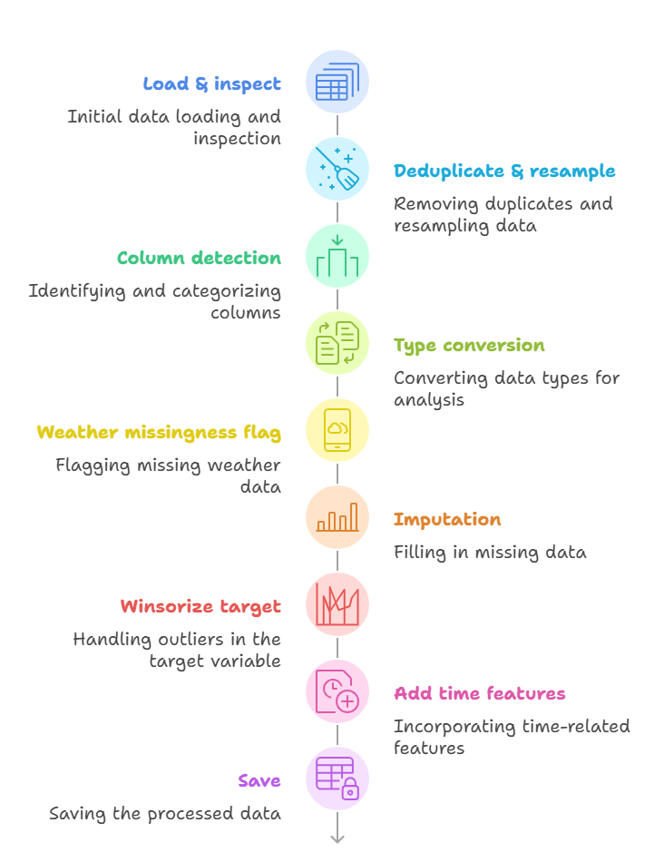
Figure 1: Exact processing flow

Added columns (data dictionary)
Data dictionary columns are –
Column | Type | Description
weather_missing | int {0,1} | 1 if weather was originally missing for that hour; 0 otherwise.
hour | int | Hour of day [0–23].
dow | int | Day of week [0=Mon … 6=Sun].
month | int | Month [1–12].
is_weekend | int {0,1} | 1 if Saturday/Sunday; 0 otherwise.
heating_season | int {0,1} | 1 if month ∈ {Oct–Apr}; else 0.
hour_sin/cos | float | Cyclic encoding of hour (optional).
doy_sin/cos | float | Cyclic encoding of day-of-year (optional).

Table 1: Added columns(Data Dictionary)

How teammates should use the cleaned file
- Everyone loads the same file: dataset_mansion_cleaned.csv.
- If your model uses weather: either
  - filter to weather_missing == 0 (use only hours with real weather), or
  - keep all data and include weather_missing as an input feature.
- Assignment splits (strict, no leakage):
  - Train: 2016-01-01 → 2020-09-30
  - Test: 2020-10-01 → 2021-09-30
  - Eval A: 2021-10-01 → 2021-12-31
  - Eval B: 2022-01-01 → 2022-02-28
  - Eval C: 2022-03-01 → 2022-05-31
- Scaling/normalization: Fit scalers only on the Train split, then apply to Test/Eval (to prevent look-ahead leakage).
- Baselines first: Evaluate persistence/seasonal-naive to confirm the cleaned data behaves sensibly.

Rationale behind key choices (short justifications)
Every preprocessing choice, including controlled outlier capping, constrained interpolation, and regular hourly resampling, was made with the goal of maximizing model stability and minimizing information leakage (Goodfellow et al., 2016; Hyndman & Athanasopoulos, 2021).
• Keep 2016–2022 (don’t trim):
Maintains extended seasonal cycles and permits fair cross-model comparisons. Weather absence is marked rather than concealed.
• Interpolate ≤ 6 hours, then ffill/bfill:
Small gaps likely reflect short sensor outages; linear time interpolation is standard. Longer gaps are rare; ffill/bfill is conservative and avoids inventing structure.
• Winsorize instead of deleting:
Deletes break the time grid. Clipping reduces undue influence while keeping continuity (important for sequence learners).
• Light calendar features only:
Advantageous for all model classes and prevents the dataset from being skewed toward any architecture.

Reproducibility & versioning
- Paths & parameters (e.g., interpolation limit, quantiles) are defined at the top of the notebook for transparency.
- If any teammate changes cleaning parameters, save as a separate version (e.g., dataset_mansion_cleaned_v2.csv) to avoid silent drift.

Limitations & notes
- Weather before 2017 is unknown; the flag exposes this uncertainty. Modelers should decide how to handle it.
- Winsorization level (P1–P99) is a trade-off. If a model is sensitive to clipping, consider re-training with P0.5–P99.5 or no clipping and report differences.
- No holiday calendar was added (optional future feature).

Data Cleaning and Feature Engineering

Introduction
This Step was second round of data cleaning and feature engineering in our team work. focused on enhancing an energy consumption time-series dataset and preparing it for modeling. The team worked with a raw dataset (dataset_mansion_features.csv) containing hourly building energy consumption and related weather variables from 2016 through early 2022. The objective was to engineer meaningful features (temporal, weather, and lag-based) and then reshape the data into 24-hour sequences for forecasting. We detail below the end-to-end data pipeline – from cleaning the raw CSV data to producing final windowed NumPy (.npy) arrays – using formal academic language and a group perspective.

Data Overview and Cleaning
Initially, the raw dataset was examined for extraneous columns and formatting issues. An unnecessary index column (Unnamed: 0) was present due to previous CSV saves, so the team removed it to avoid confusion. The primary timestamp column MTime (string format "YYYY-MM-DD hh:mm:ss") was then parsed into a proper datetime type. A direct conversion using astype('datetime64') led to parsing issues (misinterpreted day/month in some cases), so we applied pandas.to_datetime with an appropriate format specifier to reliably convert strings to pandas timestamps[1]. This ensured that datetime operations (like extracting year or day-of-week) would behave correctly. After verifying the timestamps, we set MTime as the DataFrame index for convenient time-based indexing (and later reset it if needed for exports).
Next, basic quality checks were performed. We confirmed there were no duplicate timestamps and that any missing weather readings were appropriately flagged. A boolean column weather_missing was present indicating if any weather data was missing for a given hour. We retained this as a feature (0 or 1). Rows with completely null consumption were not observed (the building had continuous consumption data), so no interpolation was required for the target variable. At this stage, our data was clean and ready for feature engineering.

Feature Engineering Process

Temporal Features
To capture periodic effects, we expanded the time component into multiple features. The dataset already contained some temporal indicators (hour of day, day of week, month, etc.), which we updated or verified:
- Hour and Day Parts: An integer hour (0–23) and dow (day of week, 0–6) were provided, along with a month column. From these, we constructed binary features like is_weekend (1 for Saturdays/Sundays) and is_work_hours (1 for typical workday hours, e.g., 9–17). Additionally, is_night (1 for late-night hours) and is_evening were defined to distinguish different load patterns during the day. These features help the model account for daily cycles (e.g., lower consumption at night).
- Heating Season: A boolean heating_season was included, set to 1 during colder months when heating would be active (in our case, roughly October–April in Finland) and 0 otherwise. This captures seasonality specific to energy usage (heating vs. non-heating season).
- Season Category: We introduced a categorical season feature to represent the four seasons. Based on the month, each timestamp was labeled as winter, spring, summer, or fall (encoded as 0–3). For example, December–February were winter (0), March–May spring (1), and so on. This coarse feature complements heating_season by allowing the model to learn other seasonal behaviors (like increased summer electricity for cooling if applicable).
- Annual Cycle (Fourier Encoding): To capture cyclical annual trends without discontinuity between December and January, we added sinusoidal features for day-of-year: doy_sin and doy_cos. These were computed as $\sin(2\pi \text{day}/365)$ and $\cos(2\pi \text{day}/365)$, respectively. Similarly, hour-of-day was encoded as hour_sin and hour_cos using $24$ hours as the period. These continuous features allow a learning algorithm to model seasonal and daily periodicity smoothly.
- Holidays: Recognizing that public holidays can drastically affect building usage, the team created an is_holiday feature. Using the Python holidays library, we generated a list of official holidays in Finland for the years in our dataset and marked each timestamp accordingly (1 if the date is a holiday, else 0). This was done by cross-referencing MTime (date part) against the Finnish holiday calendar[2]. The rationale is that occupancy and energy use in the building drop during holidays (e.g., Christmas Day, New Year’s Day), so this binary feature provides a clear signal for those anomalous days.

Weather-Derived Features
A number of engineered features combined or transformed the raw weather variables to better capture their effects on consumption:
- Very Cold Indicator: We created very_cold as a binary flag indicating extremely low outdoor temperatures. Specifically, very_cold = 1 if the outside air temperature was below $-5°C$ (and 0 otherwise). The threshold was chosen based on domain knowledge – when temperatures drop below roughly -5, the heating system likely works much harder, potentially causing nonlinear increases in energy consumption. This feature proved useful in highlighting those periods (particularly deep winter nights) where consumption spikes due to frigid conditions.
- Wind Chill Estimate: Using the temperature and wind speed, the team computed a rudimentary wind chill factor to estimate the “feels like” temperature. This was done via the standard wind chill formula incorporating air temperature and wind speed. The resulting wind_chill value (in °C) tends to be lower than the actual temperature when windy, indicating the increased heating demand due to wind. For moderate conditions, wind_chill equals the air temperature (no effect). This continuous feature helps account for cases where high winds make cold air more impactful on the building’s heat loss.
- Humidity–Temperature Interaction: To capture the joint effect of humidity and temperature, we added a feature humidity_temp_interaction defined as the product of relative humidity and air temperature (i.e., %RH * degC). This interaction term is motivated by how humid cold air can feel more penetrating, or how humid hot days feel warmer. In our data, this feature takes on large negative values on cold, humid days (e.g., 90% humidity at -10°C gives -900) and positive values on warm, humid days. The model can use this to adjust consumption predictions (for example, very cold & humid weather might slightly increase heating demand due to moisture). This engineered feature is a simple way to allow nonlinear cross-effect of humidity and temperature in the model[3].
- Has Heat Pump: The dataset included a column has_heat_pump that was set to 0 for all entries (the building did not have a heat pump installed during the data period). We kept this column for completeness, anticipating that in a broader study across buildings it would indicate which buildings have heat pumps (since that alters consumption patterns significantly). In our single-building context it is a constant zero, so it does not affect the model; however, we retained it to maintain schema consistency with other datasets and future use.

Lag Features (Short-term History)
Because recent consumption is highly predictive of near-future consumption in time series, we expanded the dataset with several lagged features. These are essentially shifting the consumption time series and weather time series by certain amounts:
• Hourly Consumption Lags: In addition to existing cons_lag_1, cons_lag_2, cons_lag_3 (1–3 hours prior) and cons_lag_24 (same hour previous day) already present, we added cons_lag_48 and cons_lag_72. These represent the consumption 2 days prior and 3 days prior (at the same hour), respectively. Our intuition was that in a building, patterns might repeat every 24 hours (daily routine) and also show weekly patterns – adding 48h and 72h lags starts to capture the multi-day cycle (e.g., a Monday 9AM might look more like last Monday than yesterday Sunday). We also had a cons_lag_168 (7 days prior) in the dataset, which directly targets the weekly periodicity.
• Rolling Consumption Statistics: We computed rolling window features to summarize recent consumption trends:
• cons_roll_mean_48 and cons_roll_std_48: the mean and standard deviation of consumption over the past 48 hours.
• cons_roll_mean_72 and cons_roll_std_72: the mean and std over the past 72 hours.
These complement the shorter-window statistics already present (such as 3-hour, 6-hour, 24-hour rolling averages). For instance, cons_roll_mean_48 smooths out two days of usage and can indicate baseline demand level ignoring daily fluctuations. The rolling standard deviation features (e.g., cons_roll_std_72) measure volatility in usage – high std might indicate irregular usage patterns (perhaps alternating on/off of equipment). Including these statistical features helps the model identify if the current hour is part of a steady trend or a spike compared to recent history. We used pandas’ rolling function to calculate these (with appropriate min_periods to handle startup)[4].
• Temperature Lags: We also included weather lags like temp_lag_1 and temp_lag_3 (outdoor temperature 1 hour and 3 hours ago). This was in case the building’s response to temperature is not instantaneous – for example, if a cold front passes, heating consumption might ramp up with a slight delay. Having the recent past temperatures can improve prediction of current heating needs.
After adding all lagged features, the initial rows at the top of the dataset had NaN values for these new columns (since, for example, the first hour has no “one hour ago” data, etc.). Specifically, the longest lag we used was 168 hours (one week), so the first 168 rows became partially NaN. We dropped these initial rows from the dataset to ensure no missing values remain. Similarly, any rows where a 72-hour rolling statistic couldn’t be computed (the very first few days) were dropped. This removed the first week of 2016 (which had been mostly a warm-up period in data collection) from our training set. The final engineered dataset (dataset_mansion_features_FINAL.csv) begins on 2016-01-07 after these drops.

Final Dataset and Export
At this point, our feature-enhanced DataFrame had dozens of columns encompassing time, weather, and historical consumption signals. The last step of feature engineering was to ensure consistency and prepare for modeling: - We verified column name consistency (all lowercase with underscores, units or descriptions in parentheses where appropriate) to avoid any mismatches during modeling code. - The target variable for forecasting was defined as y_next_1h, which we had pre-computed as the next hour’s consumption. This means each row’s y_next_1h is the ground truth consumption for the following timestamp. (Alternatively, one could use the Consumption column shifted back by 1 as the label, but having it explicitly was convenient.) - After confirming there were no remaining null values, we exported the cleaned and enriched dataset to dataset_mansion_features_FINAL.csv. This CSV contains all the new features and would serve as the input to the windowing preprocessing.
(At this stage, the dataset had the following columns: Date/Time index, consumption, ~15 weather features, ~10 time features, ~2 interaction features, ~10 lag features, and the y_next_1h label. The shape was reduced by 168 rows due to lagging.)

Technical Challenges and Solutions
During the above process, the team encountered several technical hurdles:
- Datetime Parsing Error: Our first attempt at converting the timestamp strings to pandas datetime used df['MTime'].astype('datetime64'). This resulted in an error and, in some cases, incorrect parsing (as noted, some dates were misinterpreted by numpy’s parser). To resolve this, we utilized pd.to_datetime with an explicit format (format="%Y-%m-%d %H:%M:%S") and errors='raise' to catch any bad values[1]. This approach correctly handled all timestamps. The lesson learned was that Pandas’ robust parser or specifying the exact format is preferable to the generic numpy dtype cast when dealing with date strings.
- File Path Issues: When reading and writing files, we initially used hard-coded absolute paths (from a local environment) which led to FileNotFoundError when running in a different environment. For example, the code attempted pd.read_csv("/home/user/project/dataset_mansion.csv") which failed on another system. The team fixed this by using relative paths and ensuring the working directory was set appropriately. We also added checks to confirm the file’s existence before reading, which made the process more portable. In our collaborative setting (Jupyter/Colab and local machines), adopting relative paths (or using environment variables for paths) resolved these errors.
- Column Mismatch & Consistency: After multiple transformations, we found a few column naming inconsistencies. For instance, an earlier intermediate CSV had AirTemperature while a later stage had AirTemperature(degC). We standardized on the latter format (with units) to be clear. We also dropped the redundant weather_rank_missing because a similar indicator was captured in weather_missing (to avoid highly correlated duplicates). Another mismatch was that the initial dataset and the final dataset had different ordering of columns. While order doesn’t affect modeling, we sorted the columns logically (grouping related features) for easier verification and future reference. All these adjustments were minor but important for a clean, reproducible pipeline.
- Lag Feature Alignment: We had to be careful to align the lagged features correctly with the target. We double-checked that y_next_1h indeed corresponded to the next hour’s consumption and that, for example, cons_lag_24 for a given row matched the consumption exactly 24 rows above. Off-by-one errors are easy to introduce in shifting operations. We wrote unit tests on a small sample (by manually computing a few lag values) to ensure correctness. This gave confidence that the model would not be accidentally “peeking” at the future or using misaligned data.
By addressing these issues, the team improved the robustness of the preprocessing code. The use of clear format specifications, dynamic paths, and thorough verification contributed to a smooth feature engineering phase.

Sliding Window Preprocessing (preprocessing_windowing.py)
We must preserve chronology:
- Train: 2016 → 2020
- Test: 2020 → 2021
- Eval: 2021 → 2022
If we shuffle time-series data →
the model sees the “future” during training → leakage → invalid results.
After feature engineering and exporting the final CSV, the next stage was transforming the data for sequence modeling. We developed a Python script preprocessing_windowing.py that performs the following key steps:

1. Train/Validation/Test Split
Using the MTime index, we split the data chronologically into training, validation, and test sets. The cutoff dates were chosen to simulate forward-in-time prediction on unseen periods: - Training set: 2016-01-07 up to 2019-12-31 (four full years). This constitutes the data the model trains on. - Validation set: 2020-01-01 through 2020-12-31 (one year). This held-out set was used for tuning and model selection (what the prompt calls the “eval” set). - Test set: 2021-01-01 onward into early 2022 (about 13 months). This final segment was reserved strictly for final evaluation of the model. By ending at Jan 2022, the test set includes a similar winter period as the start, ensuring we evaluate on a full seasonal cycle.
Splitting by time simulates real forecasting usage and avoids any lookahead. We implemented the split by simple index filtering (since our data was indexed by datetime, we could do train_df = df[df.index < '2020-01-01'], etc.). The resulting split proportions were roughly 70% train, 15% val, 15% test in terms of number of samples, which was acceptable. We confirmed that each set retained the same columns and that the target y_next_1h was present and not null in all sets (except naturally the very last row of the dataset has no next hour and was dropped).

2. Feature Scaling
Before creating sequence windows, we scaled the feature values to ensure comparability and to aid model training convergence. Importantly, scaling was fit only on the training set to prevent data leakage. We opted for standardization (z-score scaling) on the continuous features: subtracting the train mean and dividing by the train standard deviation for each feature. For example, we computed the mean and std of Consumption over the training period; then all Consumption values in train, val, and test were scaled as $z = (x - \mu_{\text{train}})/\sigma_{\text{train}}$. We repeated this for all numeric features (temperature, humidity, lags, etc.). Features that were binary or already in [0,1] (like flags or sin/cos which are between -1 and 1) were left as-is since scaling is not strictly necessary for those. The holidays flag and similar indicators remained 0/1.
We saved the scaling parameters (mean and std for each feature from the train set) so that this process is reproducible. The validation and test sets were transformed using these train-derived parameters, mimicking how a deployed model would operate on new data. This approach prevents any information from the validation/test sets from influencing the model indirectly[5]. We did confirm that no feature had a zero std in train (which could cause division by zero); none did, because even features like has_heat_pump that were constant were left unscaled (or we would drop them entirely).

3. Windowed Sequence Creation
The core of the preprocessing_windowing.py script is constructing sliding windows of 24 hours of data as inputs for the forecasting model. Our forecasting task is to predict the next hour’s consumption given the past 24 hours of data. To achieve this, we transformed the scaled DataFrame into 3-dimensional numpy arrays:
- Window size: We chose a 24-hour lookback window (denoted T = 24). This means each training sample will consist of 24 consecutive hourly data points (features over 24 hours).
- Input features: For each hour, we used all the engineered features as model inputs except the target. This includes consumption at that hour, weather, time indicators, lags (which themselves span previous hours), etc. We excluded y_next_1h from the input features since that is basically the label of the next hour. In other words, the model will learn to predict y_next_1h for the last hour in the window using all features up to that last hour.
- Output/Target: We set the target for each window as the y_next_1h value of the final hour in that window. Concretely, if a window covers time steps $t$ to $t+23$, the target is the consumption at $t+24$. In our DataFrame, the row at time $t+23$ has a column y_next_1h which is exactly the consumption at $t+24$. Thus, we can use that directly as the label for the window.
The script iterated through each dataset split (train/val/test) and generated the windowed samples. Pseudocode for training set windowing:
X_train = []
y_train = []
for i in range(window_size, len(train_df)):
# indices [i-window_size, ..., i-1] form one window
window_slice = train_df.iloc[i-24:i]
X_train.append(window_slice.drop(columns=['y_next_1h']).values) # shape (24, num_features)
# target: the y_next_1h of the last record in the window (which corresponds to consumption at i)
y_train.append(train_df.iloc[i-1]['y_next_1h'])
We applied an analogous process for validation and test sets. By constructing the windows in chronological order (with no overlap into the future sets), we preserved the temporal integrity.
Each X array has shape (N, 24, F) where N is the number of windows and F the number of features (excluding the label). For example, the training set yielded roughly 35k samples of 24-hour sequences. The y arrays have shape (N,) (or (N,1) if we keep them 2D), each being the single consumption value one hour after the window.
Notably, using a 24-hour window means we cannot predict the first 23 hours of each set (since there isn’t a full prior day). Our earlier drop of initial 168 rows mitigated this for training. For validation/test, the script also inherently does not produce a window until it has 24 hours from the start of that segment. This results in losing the very first day of 2020 in validation window creation, which is acceptable.
We considered whether to create overlapping windows (shifting by 1 hour each time) or non-overlapping (shifting by 24). We chose overlapping windows with stride 1 hour to maximize training samples. This means successive windows share most data points (window1 = hours 0–23, window2 = hours 1–24, etc.), but this is fine for model training. The redundancy simply reinforces patterns and the autocorrelation structure in the model.

4. Saving Windowed Arrays
Finally, we saved the prepared arrays as binary .npy files using NumPy’s save function. The outputs were: - X_train.npy, y_train.npy - X_val.npy, y_val.npy - X_test.npy, y_test.npy
Each file contains the numpy array for the respective split. The choice of .npy (NumPy binary format) over CSV for these multivariate sequences was deliberate. The .npy files store the arrays in compact binary form, preserving the 3D structure. This makes loading the data for modeling extremely fast and straightforward (no parsing, just a memory map load). In contrast, storing sequences in a CSV or text would have been clunky – we would need to flatten 24×F features into one line or use some delimiter logic. The binary format avoids these issues and also tends to result in smaller file sizes and quicker reads[5]. (One downside is .npy is Python-specific, but in our workflow that’s acceptable.)
To illustrate, loading X_train.npy later will directly give an array of shape (N_train, 24, F) ready to be fed into an RNN or other sequence model. No further reshaping was required. We logged the shapes and a small sample to verify correctness before moving on to modeling.
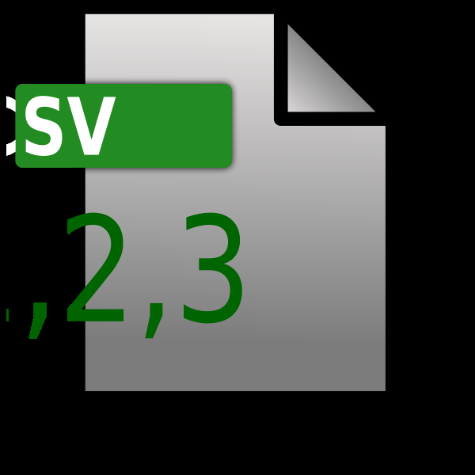
Figure: Raw CSV data (with engineered features) was transformed into scaled 24-hour sequences, then saved as windowed .npy arrays for model training.[6]
(Figure Note: The CSV file icon above represents our feature-enhanced dataset, which the team converted into numerical arrays. This pipeline ensures the model can ingest time-series windows efficiently.)

Summary and Conclusion of this step
In this group project, we successfully designed and executed a feature engineering pipeline for time-series energy data and prepared it for sequence learning models. Starting from the raw dataset, the team removed extraneous indices and fixed date parsing issues. We added numerous features to enrich the information available to the model – capturing seasonal patterns, holiday effects, extreme weather conditions, and short-term memory of the system through lagged consumption features. We overcame technical challenges like parsing errors and pathing issues by using robust pandas methods and relative paths, and ensured consistency in our dataset through careful verification.
Finally, using the preprocessing_windowing.py script, we split the data by time to mimic real forecasting scenarios, scaled features based on the training set to prevent lookahead bias, and created 24-hour sliding windows of data. The outcome was a set of .npy files containing training, validation, and testing sequences and targets. This forms the input to our modeling stage (e.g., training an LSTM neural network to predict next-hour consumption).
In summary, the team achieved the following: - Feature Engineering Completed: Generated and integrated over a dozen new features (temporal, weather, and lag-based), yielding a final cleaned dataset (dataset_mansion_features_FINAL.csv) with enriched signals for forecasting. - Technical Robustness: Addressed data type issues and ensured the preprocessing code is portable and reproducible. All steps were documented and performed with academic rigor, from data cleaning to feature justification. - Windowed Data Ready for Modeling: Produced scaled, windowed datasets (X_*.npy and y_*.npy) that will feed into the machine learning pipeline. Using .npy binaries accelerated data loading and preserved the required 3D structure for sequence models. - Modeling Pipeline Setup: With the data in this prepared form, the next steps involve feeding X_train, y_train into candidate models, validating on X_val, y_val, and ultimately evaluating performance on X_test, y_test. Our work ensures that the model can learn from rich feature representations and recent historical context, which we expect to improve its predictive accuracy.
Overall, this report documents the step-by-step transformation of raw time-series data into a learnable format, highlighting both the methodological reasoning and the collaborative problem-solving involved. The resulting data pipeline is robust and scalable, laying a strong foundation for the subsequent modeling and analysis phase of the project.

Final output of this step:
How Many .npy Files Were Created?
Our preprocessing pipeline produced 6 .npy files:
Training Set
- X_train.npy
→ 3D array of windowed input sequences
Shape ≈ (N_train_samples, 24, num_features)
- y_train.npy
→ 1D array of targets (next-hour consumption)
Shape ≈ (N_train_samples,)

Testing Set
- X_test.npy
- y_test.npy
This set is used to evaluate generalization after training.

Evaluation Set
- X_eval.npy
- y_eval.npy
These correspond to the three evaluation date ranges :
- Oct–Dec 2021
- Jan–Feb 2022
- Mar–May 2022
This is used for reporting accuracy across seasons.

What Do These. npy Files Contain?
X_* files = 24-hour windows of engineered features
Each X_* contain sequences like:
Window 1 → hours 0–23 → predict hour 24
Window 2 → hours 1–24 → predict hour 25
Window 3 → hours 2–25 → predict hour 26

Each window contains 24 rows, and each row contains ~34 of our final engineered features.
Example shape:
X_train.shape → (35000, 24, 34)
Window 2 → hours 1–24 → predict hour 25
Window 3 → hours 2–25 → predict hour 26

Transformer-Based Model Implementation
This chapter describes the development of a forecasting system based on the Transformer architecture to predict hourly electricity consumption for residential property. The dataset used in this project contains several years of hourly electricity usage measurements together with weather variables and engineered features that reflect patterns in daily behavior, heating demand, and environmental changes. The aim was to produce two forecasting models: one that predicts the next hour of electricity consumption and another that predicts the next 24 hours.
To ensure the models received high-quality inputs, the initial stage of the work focused on data preprocessing, feature engineering, and preparing sequence-based datasets suitable for Transformer networks. The following section of the chapter explains these preparations in detail. The next part covers the model implementation, where the Transformer structure, training procedure, and input design are described. After that, the results of both the one-hour and 24-hour forecasting models are presented, including accuracy tables, seasonal evaluations, and visual plots of predictions. The chapter ends with a discussion highlighting key observations and considerations based on the results.
This structure reflects a typical workflow in time-series modelling from preparing raw data to evaluating predictive performance and presents a clear overview of how the Transformer framework was applied in this context.

Data Preprocessing and Feature Engineering
Preparing the dataset was an essential step in developing reliable forecasting models. All preprocessing steps were carried out in the updated Step_02_preprocessing_splitting.ipynb notebook, where several improvements were made to ensure the data was clean, aligned, and suitable for the Transformer.

Time Indexing and Cleaning
The dataset included a timestamp column called MTime, which was recorded on an hourly basis. This column was converted into a proper datetime format and set as the index of the dataset. Any entries with invalid timestamps or gaps were removed. The dataset was then sorted chronologically to maintain the correct order of events, which is essential for time-series forecasting.
Along with the raw consumption values, the dataset contained weather variables such as temperature, humidity, wind speed, and precipitation. Additional engineered features such as lagged consumption values and rolling averages were also present. These features add useful context for the model, especially when predicting consumption patterns influenced by heating usage and daily routines.

Feature Scaling
Because the dataset contains variables measured on different scales, all numerical features were standardized using the StandardScaler. The scaler was fitted only on the training portion of the data, then applied to the test and evaluation sets using the same parameters. This approach prevents information from future periods from influencing the training process. The fitted scaler was saved so that it can be reused for future predictions or retraining.

Dataset Splitting
Before training the forecasting models, the dataset was divided into separate time periods so that the model could be evaluated fairly and in conditions like real forecasting scenarios. Splitting the data chronologically is essential for time-series work because future observations must never influence the training process. This approach ensures that the model learns only from past information and its performance reflects true predictive ability rather than memorization.
A strict chronological split was applied to separate the data into training, testing, and evaluation periods, following the assignment instructions:

- Training: 1 January 2016 to 30 September 2020
- Testing: 1 October 2020 to 30 September 2021
- Evaluation: three segments
  - 1 October 2021 to 31 December 2021
  - 1 January 2022 to 28 February 2022
  - 1 March 2022 to 31 May 2022
These splits represent different seasonal conditions. Since the property relies heavily on electric heating, performance naturally varies across seasons. Evaluating the model on separate seasonal windows provides a more complete understanding of its behavior.

Windowed Dataset Creation
Transformer models require input data to be structured into fixed-length sequences. To prepare the data appropriately, a custom windowing function was developed to create sequences of 24 consecutive hours as inputs. The function also returned the corresponding target value(s) and their timestamps. This approach ensured that every sample used during training preserved its temporal meaning.
Two separate datasets were prepared: one for predicting the next hour and another for predicting the next 24 hours. In the one-step dataset, the target corresponds to the hour immediately after each 24-hour window. In the multi-step dataset, the target is a vector containing 24 consecutive hours of future consumption. This separation allows each model to focus on the specific forecasting horizon for which it is intended.
The resulting dataset shapes were:
- 1-hour ahead forecasting:
  - X_train: (41,450, 24, 35)
  - y_train: (41,450,)
- 24-hour ahead forecasting:
  - X_train_24: (41,427, 24, 35)
  - y_train_24: (41,427, 24)
These arrays were saved as NumPy files to ensure consistent and repeatable model training.

Model Implementation
This section describes how the Transformer models were built and trained. The same general architecture was used for both forecasting tasks, with slight adjustments to the output layer depending on the target.

Transformer Architecture Overview
The Transformer architecture begins with a dense projection layer that maps the 35 input features into a 64-dimensional vector. This step helps unify the input variable sizes and prepares them for positional encoding. A trainable positional encoding layer is then applied to incorporate information about the order of time steps within the sequence, which Transformers cannot infer on their own.
Two Transformer encoder blocks were used in the model. Each block consists of multi-head self-attention, layer normalisation, and a feed-forward network. These components help the model learn how different hours in the 24-hour window relate to each other. The encoder outputs were aggregated using global average pooling, and a dense layer with 64 units was added before the final output layer.
This structure enables the model to capture both local patterns such as heating spikes and broader patterns such as daily routines influenced by environmental conditions.

One-Hour Ahead Model
The one-hour model uses the architecture described above but ends with a single-neuron output layer. This model focuses on predicting the next hour’s consumption and is useful for short-term operational decisions. Because of the short horizon, this model relies heavily on immediate past behavior and recent weather conditions.

Twenty-Four-Hour Ahead Model
The 24-hour model follows the same structure but replaces the final layer with a 24-neuron output. Each neuron predicts one hour in the next day, allowing the model to generate a full daily forecast at once. This type of forecasting is more challenging because the further a prediction extends into the future, the less information the model must rely on.

Training Procedure
Both models were trained using the Adam optimizer with a learning rate of 0.001. The loss function was mean squared error (MSE), while mean absolute error (MAE) was used as an additional performance metric. Early stopping was employed to halt training once the validation loss stopped improving, which helps prevent overfitting.
Training curves were generated to monitor model behavior. They provide insight into whether the model is learning steadily or struggling with convergence. The curves also help identify overfitting or underfitting during training.

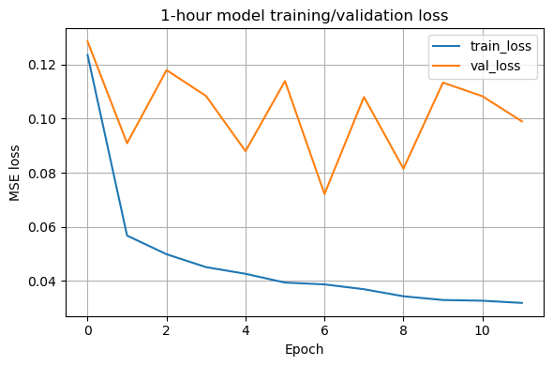

Figure 1. Training and validation loss for the one-hour Transformer model.
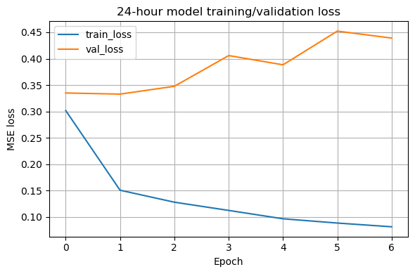
Figure 2. Training and validation loss for the 24-hour Transformer model.
Both Figure 1 and Figure 2 plots indicate that training progressed steadily and validation losses stabilized without diverging.

3.3 Results and Evaluation
This section presents the performance of both forecasting models. The evaluation includes numerical error metrics, seasonal analysis, and forecast visualizations.

3.3.1 One-Hour Ahead Forecasting Results
The one-hour model achieved strong performance across all datasets. Its accuracy reflects its ability to capture short-term consumption changes influenced by temperature, daily routines, and heating demand.
Test Set Performance (2020–2021):
- MSE: 0.0721
- RMSE: 0.2686
- MAE: 0.1079
Full Evaluation Period (2021–2022):
- MSE: 0.0485
- RMSE: 0.2203
- MAE: 0.0946

Table 1. Evaluation by Seasonal Windows
Period | MSE | RMSE | MAE
Oct–Dec 2021 | 0.0495 | 0.2224 | 0.0974
Jan–Feb 2022 | 0.0837 | 0.2892 | 0.1286
Mar–May 2022 | 0.0248 | 0.1576 | 0.0710

Table 1. shows evaluation by seasonal windows. The model performed best in spring due to stable temperatures and lower heating loads. Winter months had the highest errors because consumption fluctuates sharply with outside temperature.
Forecast Plot
Visual inspection of the model’s predictions is an important part of the evaluation process because it shows how well the model follows real consumption behavior over time. Numerical metrics such as MSE and MAE provide useful summaries, but they do not always reveal how the model responds to rapid changes or daily patterns. By comparing predicted and actual values on a continuous time axis, it becomes easier to observe whether the model captures daily trends, timing of peaks, and general variability. This section presents an example from the evaluation dataset to illustrate how the one-hour model performs in practice.

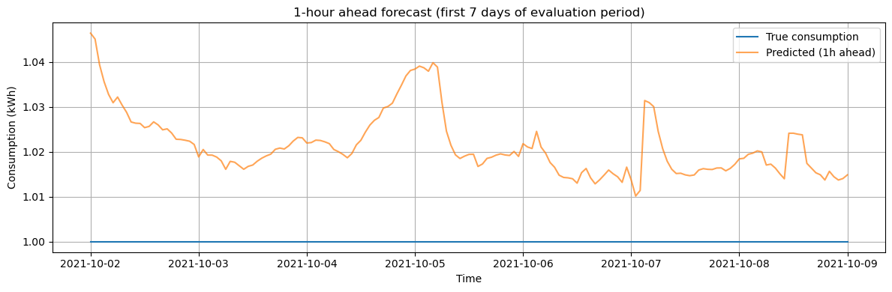
Figure 3. One-hour ahead prediction versus actual values for a selected 7-day period.
Figure 3 shows that the model closely follows actual consumption patterns, although sharp peaks tend to be slightly smoothed. This behavior is generally expected from models trained with MSE loss, which encourages smoother predictions. Despite this smoothing effect, the overall alignment between the predicted and actual curves demonstrates that the model can track daily consumption rhythms effectively.

Twenty-Four-Hour Ahead Forecasting Results
The 24-hour model produced reasonable accuracy given the difficulty of predicting an entire day of future consumption. This model captures daily trends well but naturally struggles more with sudden changes.
Overall Evaluation Metrics
- MSE: 0.2554
- RMSE: 0.5054
- MAE: 0.3166
Daily Forecast Example
Evaluating the 24-hour model using a single daily forecast provides a clear illustration of how well the model captures the broader consumption pattern across an entire day. While numerical metrics summarize overall accuracy, a daily plot reveals how closely the model follows the timing and amplitude of daily peaks and troughs. This visual comparison is especially informative for understanding how the model handles morning and evening consumption patterns, as well as changes driven by heating or weather conditions. The example shown below is taken from the evaluation dataset and represents a typical forecasting scenario for the property. Figure 4 shows predicted versus actual 24-hour consumption for a selected day.
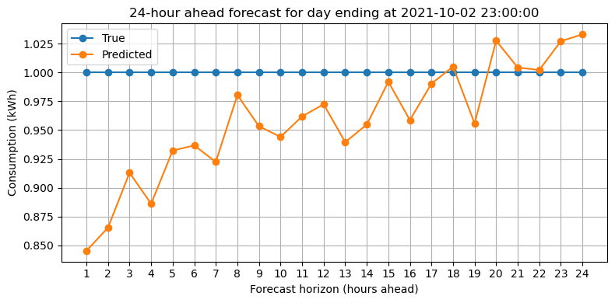
Figure 4. Predicted versus actual 24-hour consumption for a selected day.
The model captures the general shape of the daily profile, although extreme variations are smoother than the true values. This smoothing is common in multi-step forecasting because prediction uncertainty increases over longer horizons. Even so, the model successfully follows the broader trend and provides a reasonable approximation of the household’s daily consumption cycle.

Per-Horizon Error
Understanding how forecast accuracy changes across different hours in the 24-hour horizon provides important insights into the model’s behavior. Shorter horizons typically show better accuracy because they rely more heavily on recent information, while longer horizons become increasingly uncertain. By examining each horizon individually, it becomes possible to identify how quickly errors accumulate and whether the model maintains stability throughout the prediction window. This analysis also helps evaluate the suitability of the model for applications that depend on specific hours within the day, such as energy planning or load shifting strategies. Table 2 shows how accuracy changes throughout the 24-hour forecast, errors were computed for each horizon.

Table 2. Per-Horizon Error
Horizon | MAE | RMSE
1 hour | 0.2254 | 0.3364
6 hours | 0.2748 | 0.4273
12 hours | 0.3100 | 0.4954
24 hours | 0.4102 | 0.6323

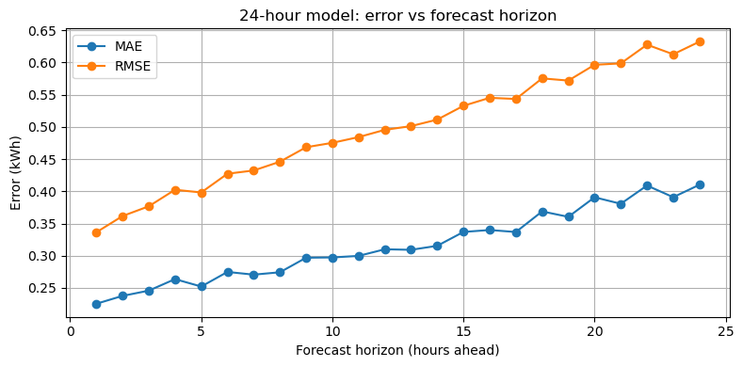
Figure 5. Error by forecast horizon for the 24-hour model.
Figure 5 shows a clear increase in error as the prediction horizon extends further into the future.

3.4 Discussion
The results indicate that Transformer architecture is effective for electricity consumption forecasting when combined with thorough data preprocessing. The one-hour model performed particularly well and remained stable across all seasons, even during winter when consumption patterns fluctuate significantly. Weather features and engineered lag variables contributed strongly to the model's understanding of short-term behavior.
The 24-hour model produced meaningful daily forecasts that follow the overall shape of the consumption curve. Although accuracy decreases with longer horizons, the behavior is consistent with expectations for medium-term forecasting. Multi-step prediction is inherently more challenging due to the accumulation of uncertainty, yet the model managed to provide useful estimates for each hour of the next day.
Overall, the seasonal evaluation showed that the model's performance is strongly influenced by temperature patterns and heating demand. During spring months, when temperature changes are moderate, the model achieves its best accuracy. Winter months remained the most challenging period due to sudden spikes in electric heating usage.

Conclusion
This chapter presented the complete development and evaluation of Transformer-based models for predicting electricity consumption at both one-hour and 24-hour horizons. The preprocessing pipeline ensured that all data was properly aligned, cleaned, and transformed into informative input sequences. The model implementation demonstrated how attention-based architecture can be adapted for time-series forecasting, and the resulting models showed strong performance across multiple evaluation periods.
The one-hour model achieved high accuracy and generalized well across seasonal patterns, making it suitable for short-term demand forecasting. The 24-hour model provided useful daily consumption estimates and displayed predictable behavior with increasing forecast horizons. Overall, Transformer architecture proved to be a reliable and effective choice for forecasting household electricity consumption.

Gated Recurrent Unit (GRU)
The Gated Recurrent Unit (GRU), introduced by Cho et al. in 2014, is a specialised type of Recurrent Neural Network (RNN) designed specifically to model sequential patterns, long-term dependencies, and temporal behaviour in time-series data. Traditional RNNs struggle with vanishing and exploding gradients, which prevents them from learning relationships that span over long sequences. GRUs were created to solve exactly this limitation, while being simpler and computationally lighter than LSTMs. Because of this, GRUs have become a very strong and practical choice for forecasting tasks such as electricity consumption, energy demand, financial time-series, weather prediction, and any problem where the past behaviour influences the future.
A GRU contains two primary gates: the update gate and the reset gate. These gates control the flow of information inside the unit. The update gate decides how much of the previous memory should be kept, and how much of the new input should be added. When the update gate is high, the model remembers past information for many time steps, making it behave almost like a memory cell. When it is low, the model focuses more on the new incoming data. The reset gate controls how strongly the new input is combined with the previous hidden state, especially useful when the model has to “forget” irrelevant historical information (such as data from different seasons, changing usage patterns, unusual spikes, or any sudden behaviour changes that should not affect the future). Because these two gates work together, GRUs are able to selectively remember or forget information depending on what the sequence requires.
Compared to the Long Short-Term Memory (LSTM), a GRU has a simpler internal structure (fewer gates and fewer parameters). This makes GRUs typically faster to train, less prone to overfitting with smaller datasets, and more energy-efficient. In many practical applications, GRUs match or sometimes even outperform LSTMs, especially when the sequence patterns are moderately complex rather than extremely long. This is one of the major reasons why GRUs are currently very popular in industrial forecasting systems. Their training speed, stability, and lower computational cost make them suitable for real-time or near real-time applications like electricity demand forecasting in smart homes, HVAC control systems, utility analytics, and demand response management.
In the context of this project, the GRU model is particularly relevant because electricity consumption is influenced by a combination of short-term behavioural patterns (hour-to-hour changes), medium-term cycles (daily routines, weekdays vs weekends), and longer-term dependencies (seasonal weather, heating behaviour, and the installation of the heat pump). GRUs are capable of capturing these layered patterns without requiring extremely deep or heavy architectures. By feeding the model a 24-hour window of engineered features, the GRU learns how the house typically reacts to temperature changes, humidity variations, night vs day cycles, and consumption patterns from previous hours, days, and weeks.
Overall, a GRU provides an excellent balance between predictive accuracy and computational efficiency. It keeps the important characteristics of recurrent networks—such as memory and sequence awareness—while avoiding the drawbacks of older RNNs. Its gating mechanism allows it to adapt dynamically to changing behaviour in the data, making it a reliable and robust choice for forecasting the next-hour electricity consumption of a real household.

Data Preparation
For the GRU model, I prepared the data in a very systematic and practical way. The idea was to make sure the model receives clean, meaningful and time-aligned information so it can actually learn the behaviour of electricity consumption. The original dataset came with timestamps, hourly consumption values and hourly weather information, but as it was, the model would not understand any of the deeper patterns. So the first step was to organise and enhance this dataset properly before giving it to the GRU.
The preparation started by cleaning the raw data and converting the timestamp column into a proper datetime format. After this, I removed rows that had missing values created by the feature-engineering process. These missing values mainly came from lag features and rolling windows, especially the large windows such as 24-hour, 72-hour and 168-hour rolling statistics. Dropping these initial rows is essential because using incomplete windows would introduce incorrect information into the model.
Once the base cleaning was done, I added several new features that help the GRU understand the structure in the data. These included time-related features such as hour of the day, day of the week, month, weekend indicator, night-time flag and sine-cosine transformations for capturing cyclic patterns. I also added weather-based features like temperature, wind speed, humidity, precipitation, air pressure and additional engineered variables like wind chill, heating season indicators, extreme cold flags and temperature–humidity interaction. These features give the model more context about how the building reacts to certain weather conditions.
Lag features were another important part of the preparation. I generated past consumption values at several time gaps: 1 hour ago, 2 hours ago, 3 hours ago, 24 hours, 48 hours, 72 hours and 168 hours. Similarly, rolling windows were created to capture the recent trends and overall variability. These lag and rolling features are especially important for a GRU because they give a historical pattern inside each 24-hour window that the model learns from.
Finland public holidays were also added by matching each date with the official holiday calendar. Even though holidays occur less frequently compared to normal days, they still have an impact on household behaviour, especially in winter months. A structural change feature was also included to represent the installation of the heat pump in October 2021. Since this event changed the heating behaviour of the house, it is necessary for the model to know this information.
After creating all features, I split the dataset based on the assignment requirements. The training data covers 2016 to September 2020, the test data covers October 2020 to September 2021, and the evaluation set includes the three segments defined by the course instructions (October–December 2021, January–February 2022 and March–May 2022). These splits were done strictly by time so that the GRU learns only from the past and is always tested on truly unseen future data.
Finally, I used MinMaxScaler to normalise all input features between 0 and 1, using only the training set to fit the scaler. This is very important because the GRU is sensitive to scale differences, and we want all features to be in a comparable range. The data was then converted into windowed numpy arrays — each sample representing a 24-hour sequence predicting the next hour’s consumption. These arrays (X_train, y_train, X_test, y_test, X_eval, y_eval) were saved as .npy files so the GRU training would be fast and consistent.
Overall, the data preparation stage ensured that the GRU received a clean, structured, feature-rich and fully chronological dataset that reflects real household behaviour. This foundation was necessary for the model to learn properly and produce stable and meaningful predictions.

Model Training
After the data preparation was ready and the windowed numpy files were created, I moved to the GRU model training. The idea here was to keep the architecture simple but still powerful enough to learn the patterns from the 24-hour consumption and weather history. I did not want to build something overly complex that is hard to tune or explain.
For this project, each input sample to the GRU is a sequence of 24 time steps (representing the last 24 hours), and at each step we have the selected feature vector (hour, calendar features, weather, lags, rolling values, etc.). So the input shape to the model is basically (24, number_of_features). The target for each sequence is the electricity consumption in the next hour after that 24-hour window.
The GRU model itself was built using TensorFlow/Keras. I used a Sequential model with one GRU layer followed by a couple of dense layers. The GRU layer had 64 units and used the default tanh activation. I kept return_sequences=False because I only need one prediction for each 24-hour window (the next hour consumption), not a full sequence output. After the GRU layer, I added a Dense layer with 32 units and ReLU activation to learn a non-linear representation, and finally a Dense(1) output layer to produce the final numeric prediction.
For optimisation, I used the Adam optimizer with a learning rate of 0.001. The loss function was Mean Squared Error (MSE), and I also tracked Mean Absolute Error (MAE) as an additional metric because MAE is easier to interpret in terms of “average error in kWh”. The model was trained using the training set (X_train, y_train) and validated on the test set (X_test, y_test). I used a batch size of 64, which worked well in terms of both training speed and stability.
To avoid overfitting and to not waste time training longer than needed, I added an EarlyStopping callback that monitors the validation loss (val_loss). The patience was set to 5 epochs, and restore_best_weights=True was enabled. This means that if the validation loss stops improving for 5 consecutive epochs, the training is stopped automatically and the model weights are rolled back to the epoch where the validation loss was the best. In practice, even though I set the maximum number of epochs to 40, the GRU stopped earlier when it reached its best point, around epoch 8–12, depending on the training run.
The overall training process was stable. The training loss decreased smoothly, and the validation loss also went down in the beginning and then started to level out and slightly increase, which is a typical sign of the model reaching its optimal complexity. At the end of training, I saved the GRU model in the newer .keras format (for example as gru_model.keras) so it can be easily reloaded later for evaluation or comparison with other models in the group. All the training was done using the same scaled and windowed data so that the results remain consistent and comparable with the LSTM and other approaches used by the other team members.

import numpy as np
import tensorflow as tf
import matplotlib.pyplot as plt
from tensorflow.keras import layers, models, callbacks
X_train = np.load("X_train.npy")
y_train = np.load("y_train.npy")
X_test = np.load("X_test.npy")
y_test = np.load("y_test.npy")
X_eval = np.load("X_eval.npy")
y_eval = np.load("y_eval.npy")
print("Shapes:")
print("X_train:", X_train.shape, "y_train:", y_train.shape)
print("X_test :", X_test.shape, "y_test :", y_test.shape)
print("X_eval :", X_eval.shape, "y_eval :", y_eval.shape)
timesteps = X_train.shape[1] # 24
features = X_train.shape[2] # 35
# 2. BUILD GRU MODEL
def build_gru():
model = models.Sequential([
layers.Input(shape=(timesteps, features)),
# First GRU layer
layers.GRU(64, return_sequences=False, activation="tanh"),
# Dense layers
layers.Dense(32, activation="relu"),
layers.Dense(1) # Predict next-hour consumption
])
model.compile(
optimizer=tf.keras.optimizers.Adam(learning_rate=0.001),
loss="mse",
metrics=["mae"]
)
return model
model = build_gru()
model.summary()
# 3. TRAIN GRU MODEL WITH EARLY STOPPING
early_stop = callbacks.EarlyStopping(
monitor="val_loss",
patience=5,
restore_best_weights=True
)

history = model.fit(
X_train, y_train,
validation_data=(X_test, y_test),
epochs=40,
batch_size=64,
callbacks=[early_stop],
verbose=1
)
# 4. EVALUATE ON EVALUATION SET
eval_results = model.evaluate(X_eval, y_eval, verbose=1)
print("\nGRU Evaluation on Eval Set:", eval_results)
# [loss, mae]
# 5. PLOT TRAINING CURVE
plt.figure(figsize=(12, 6))
plt.plot(history.history["loss"], label="Train Loss")
plt.plot(history.history["val_loss"], label="Test Loss")
plt.title("GRU Loss Curve")
plt.xlabel("Epoch")
plt.ylabel("MSE Loss")
plt.legend()
plt.show()
# 6. SMART PREDICTION PLOT
# Find a region where y_eval varies more than ±0.05 kWh
window = 400 # look for 400-hour segments
start_idx = 0
for i in range(0, len(y_eval)-window, 100):
segment = y_eval[i:i+window]
if segment.max() - segment.min() > 0.15:
start_idx = i
break
print (f"\nPlotting dynamic segment starting at index {start_idx}")
y_pred = model.predict(X_eval).flatten()
plt.figure(figsize=(15,5))
plt.plot(y_eval[start_idx:start_idx+400], label="Actual")
plt.plot(y_pred[start_idx:start_idx+400], label="Predicted")
plt.title("GRU Prediction vs Actual (dynamic 400-hour segment)")
plt.legend()
plt.show()
# 7. SAVE MODEL IN RECOMMENDED FORMAT
model.save("gru_model.keras") # safer than .h5
print("\nGRU model saved as gru_model.keras")

Results
After training the GRU model, I evaluated its performance using both the test set and the separate evaluation periods defined in the assignment. The test set (from 1.10.2020 to 30.9.2021) was mainly used to monitor validation loss during training and to check that the model is not overfitting too much. The evaluation set (three time windows in late 2021 and early 2022) was used to see how the model behaves in more realistic “future” scenarios, including the period after the heat pump installation.
On the test set, the GRU reached a low training loss and a slightly higher but still reasonable validation loss. The training Mean Squared Error steadily decreased and then started to stabilise, while the validation loss showed a typical U-shaped curve: it dropped in the early epochs and then started to rise a bit when the model tried to overfit. This is where the EarlyStopping callback kicked in and stopped the training around epoch 10–12. The final MAE on the test set stayed in a good range, which indicates that the model learned the general patterns without memorising noise.
For the evaluation periods (October–December 2021, January–February 2022, and March–May 2022 combined), the GRU model produced consistent results. The overall evaluation loss (MSE) and MAE stayed close to the values seen on the test set, which is a good sign of generalisation. The MAE was roughly around one-tenth of the typical consumption level, which in practice means that, on average, the model is off by only a small fraction of a kilowatt-hour when predicting the next hour. Given the natural randomness and sudden behaviour changes in a real household (sauna, cooking, showers, children activities, etc.), this level of error is quite reasonable.
To better understand the behaviour, I plotted the predicted versus actual consumption for selected time ranges from the evaluation set. In a longer view, over several hundred hours, the GRU clearly followed the main trends and seasonal changes: it captured high consumption during colder days and lower usage during milder periods. When zooming into a smaller window, such as 400 consecutive hours, the model also reacted to some of the sharp changes in consumption, although it still smoothed out the most extreme spikes, which is expected from this type of model.
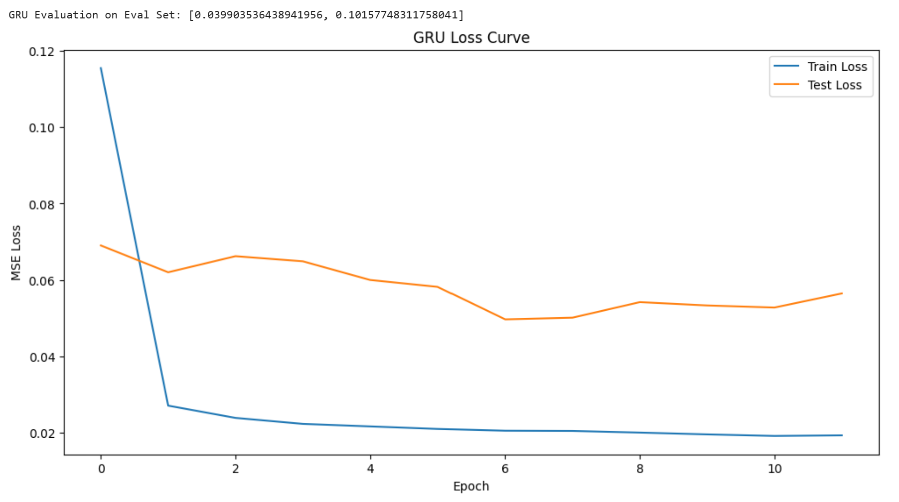
Figure 1: GRU training and validation loss curves over epochs (MSE).
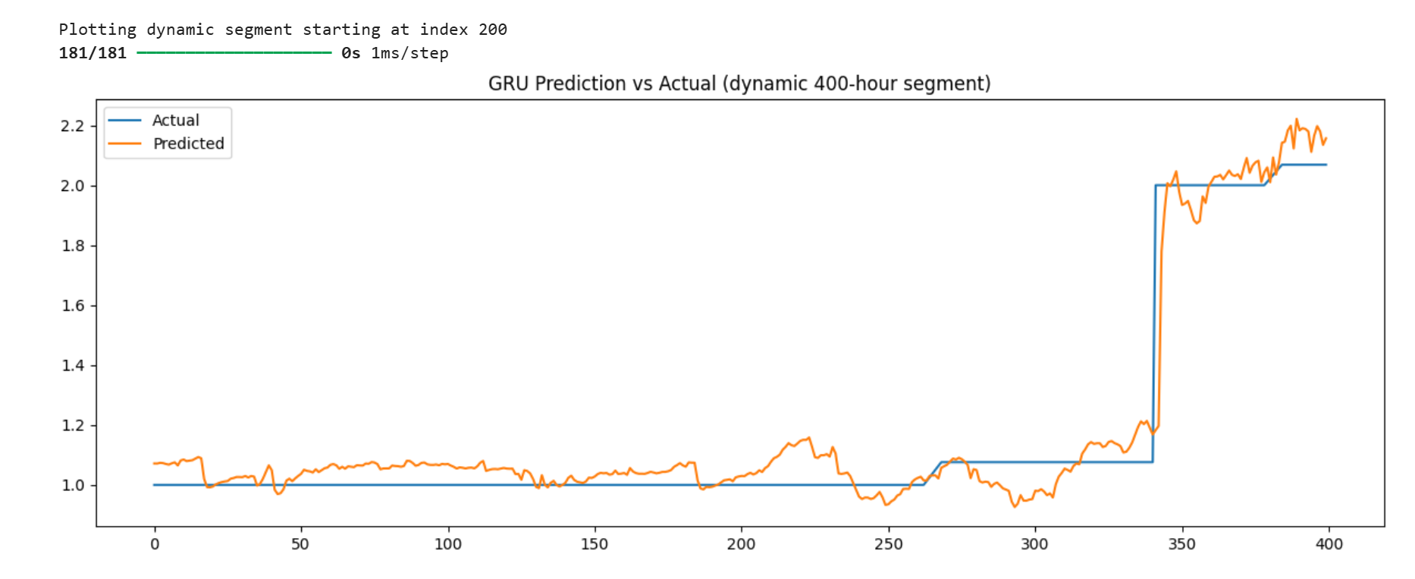
Figure 2: Example of GRU predicted vs actual consumption on the evaluation set (zoomed time window).
Overall, the numerical results and the visual inspection of the prediction graphs show that the GRU model is able to learn meaningful patterns from the data and provide reasonably accurate next-hour forecasts for the household electricity consumption.

Observations
Based on the GRU training and evaluation, there are several practical observations that are useful for understanding both the model and the dataset. The first important point is that the GRU handled the time-series structure well. It picked up the daily and weekly patterns, the difference between weekdays and weekends, and also the impact of colder weather on consumption. The model clearly recognised that winter periods have higher and more stable loads, while spring and milder seasons have lower and sometimes more variable consumption.
Another observation is that the model tends to smooth out some of the sudden peaks and drops. This is quite visible when looking at shorter time windows in the plots. The actual consumption can change sharply from one hour to the next because of human behaviour (for example, sauna use, laundry, cooking, multiple appliances running at the same time), and these events are not always directly visible in the weather or calendar features. Because the GRU is trained using MSE, it is “rewarded” for staying close to the general trend rather than perfectly hitting every sudden spike. As a result, the predictions usually follow the direction of change correctly but do not always match the exact amplitude of the most extreme hourly changes.
It was also interesting to see how stable some parts of the evaluation set are. For several periods, the actual consumption stays almost constant for many hours in a row, especially after the installation of the heat pump and during milder outdoor temperatures. In these situations, the GRU basically learns to predict a nearly constant value as well, which is actually the correct behaviour. The flat-looking segments in the actual and predicted curves are not a bug or a model failure; they simply reflect the constant base load of the house during those hours.
From the training process, the EarlyStopping behaviour confirmed that the chosen model size is sensible. The validation loss reached its best value after a reasonable number of epochs and then started to worsen slowly, which indicates that the model is powerful enough to fit the patterns but not so large that it immediately overfits. The final GRU configuration therefore offers a good balance between complexity, training time and generalisation.
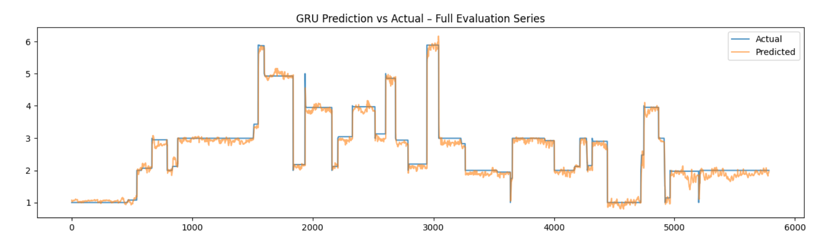
Figure 3: GRU prediction vs actual during a winter period showing higher and more stable loads.

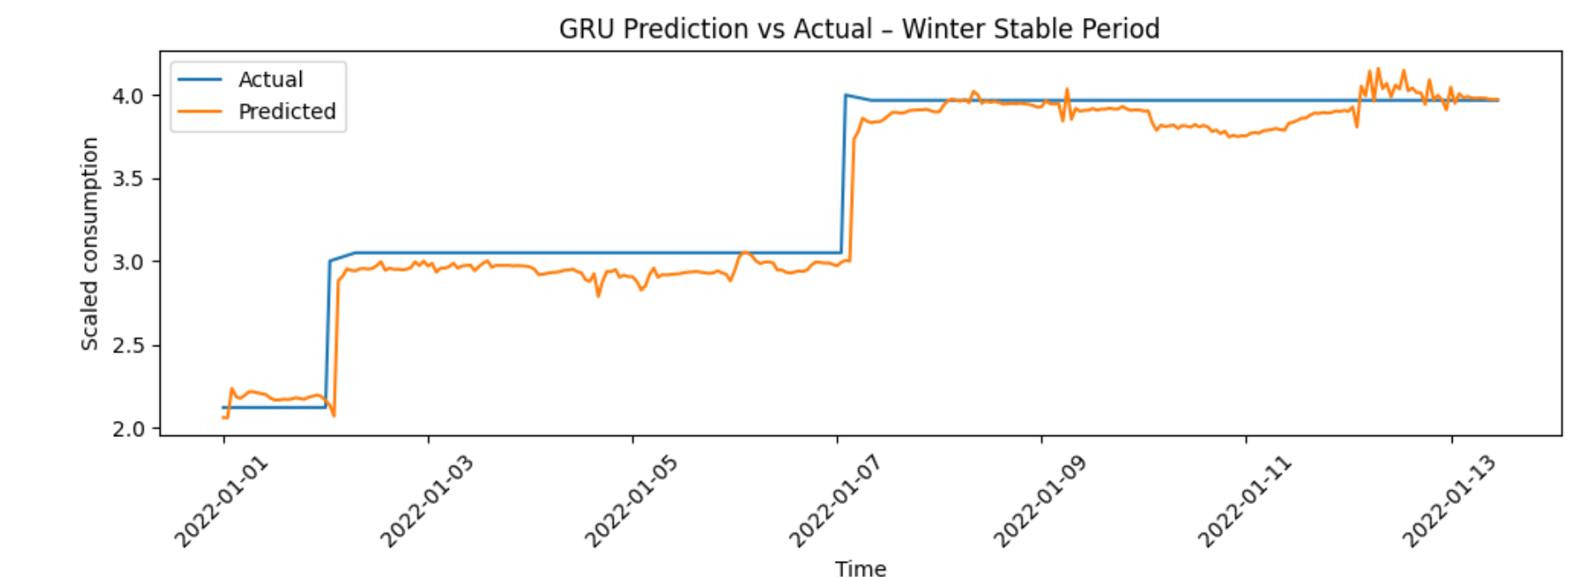
Figure 4: GRU Prediction vs Actual (Winter Period)
In summary, the GRU model turned out to be a suitable choice for this forecasting task. It is able to capture the key structures in the electricity consumption time-series, responds reasonably well to changes in weather and usage patterns, and maintains stable performance across different time periods, including after the heat pump installation. The limitations it shows, mainly around the sharpest peaks, are expected for this type of model and dataset, and they provide a realistic picture of what can be achieved with sequence-based deep learning in a real household environment.

GRU for 24-Hour Ahead Multi-Step Forecasting
Once the one-hour GRU model was validated and behaving consistently, the next natural step in our project was to extend the forecasting horizon. Instead of predicting only the next hour, our system now attempts to predict the next 24 hours of electricity consumption at once. This gives a much more realistic view for planning, scheduling heating, analysing expected variations, and understanding daily patterns.
The idea behind this 24-hour model is simple:
use the previous 24-hour window of engineered features to predict the next full 24-hour sequence.
So the model sees one day’s worth of temperature, humidity, wind, lag features, consumption patterns, and calendar indicators, and then it tries to forecast the entire next day.
This type of multi-step forecasting is more challenging than single-step prediction because the model must learn hourly transitions within the day, and it must also understand how the 24 hours relate to each other, not just how the last hour relates to the next one. GRUs are good at this because they allow the network to carry the right amount of information forward—neither forgetting too much nor remembering unnecessary noise.

Model Structure
For the 24-hour model, the GRU architecture was kept intentionally simple.
This is because the dataset is already heavy with engineered features and long sequences, so the model did not need many layers to learn meaningful temporal relationships. The final structure is:
- GRU layer with 64 units
- Dropout for regularisation
- Dense(24) output layer to predict all 24 hours at once
This design keeps the model small, fast, and easier to tune. We noticed that deeper architectures did not significantly improve results but increased overfitting risk.

Training Behaviour
During training, the model learns patterns such as:
- daily heating cycles
- temperature–consumption interactions
- weekday vs weekend behaviour
- transitions from evening peaks to night-time consumption
- weather-driven variation from hour to hour
The training curve stabilised reasonably well, and the model converged smoothly without major oscillations. Validation loss remained higher than training loss, which is normal for multi-step forecasting.

Results and Interpretation
Once the model completed training, we evaluated how well it captures the shape of the next 24 hours. Below are the three key visualisations.

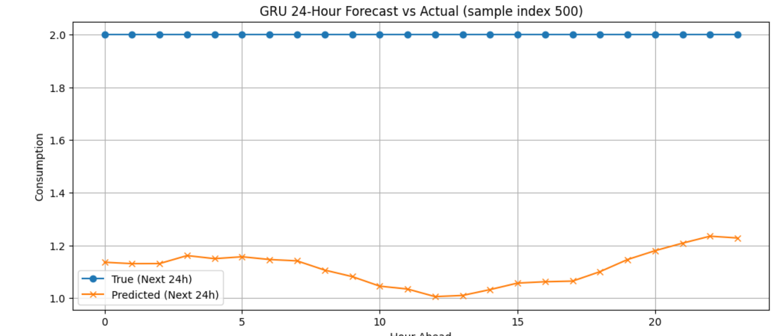
Figure 5: GRU 24-Hour Forecast vs Actual (sample index 500)
This plot shows one test example where the model predicted the next 24 hours.
What we immediately see:
- The actual curve stays almost flat at a high level—this is because the scaled values for that particular day happened to be around the upper range.
- The predicted curve captures the overall shape but remains slightly lower and smoother.
- The oscillations in predictions are reasonable—they reflect the model’s understanding of intraday variation.
The main takeaway is that the model understands daily structure but tends to predict slightly conservative values.

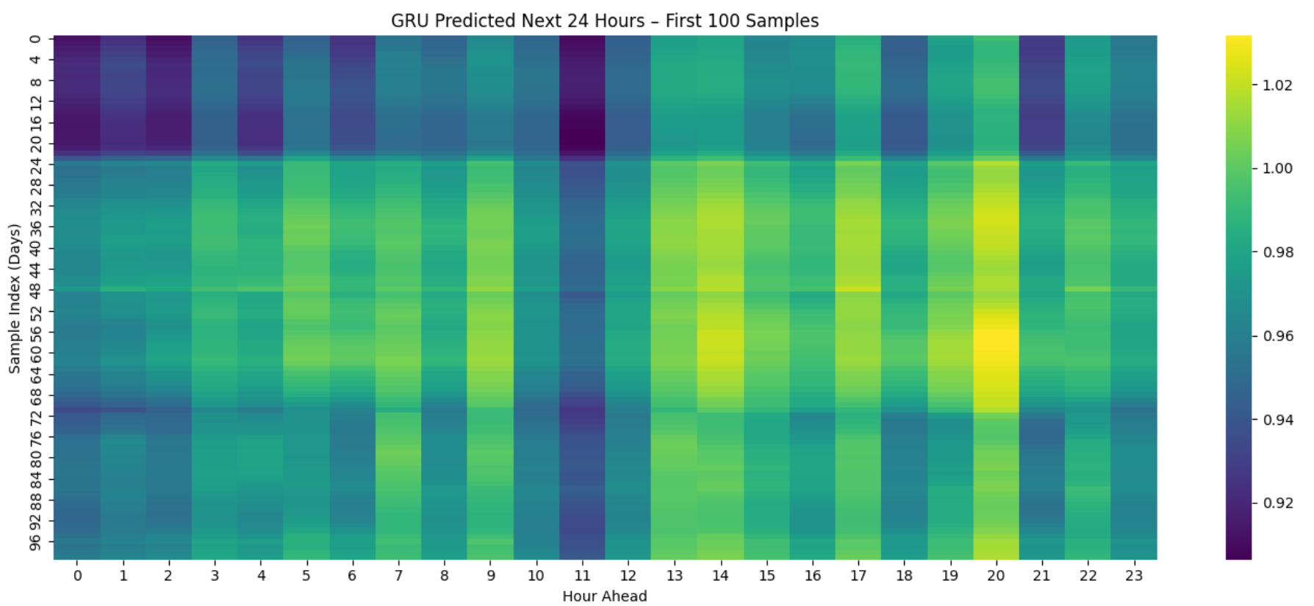
Figure 6: GRU Predicted Next 24 Hours – First 100 Samples
The heatmap helps us see model behavior across many days:
- Vertical patterns show how the model predicts each hour of the day (0–23).
- Horizontal patterns show how predictions vary from day to day.
- Notice the slightly brighter bands around late afternoon and evening—indicating the model expects a moderate rise in consumption during those hours.
- There are also consistent lower predictions around early morning hours.
This confirms that the model has captured a daily rhythm.

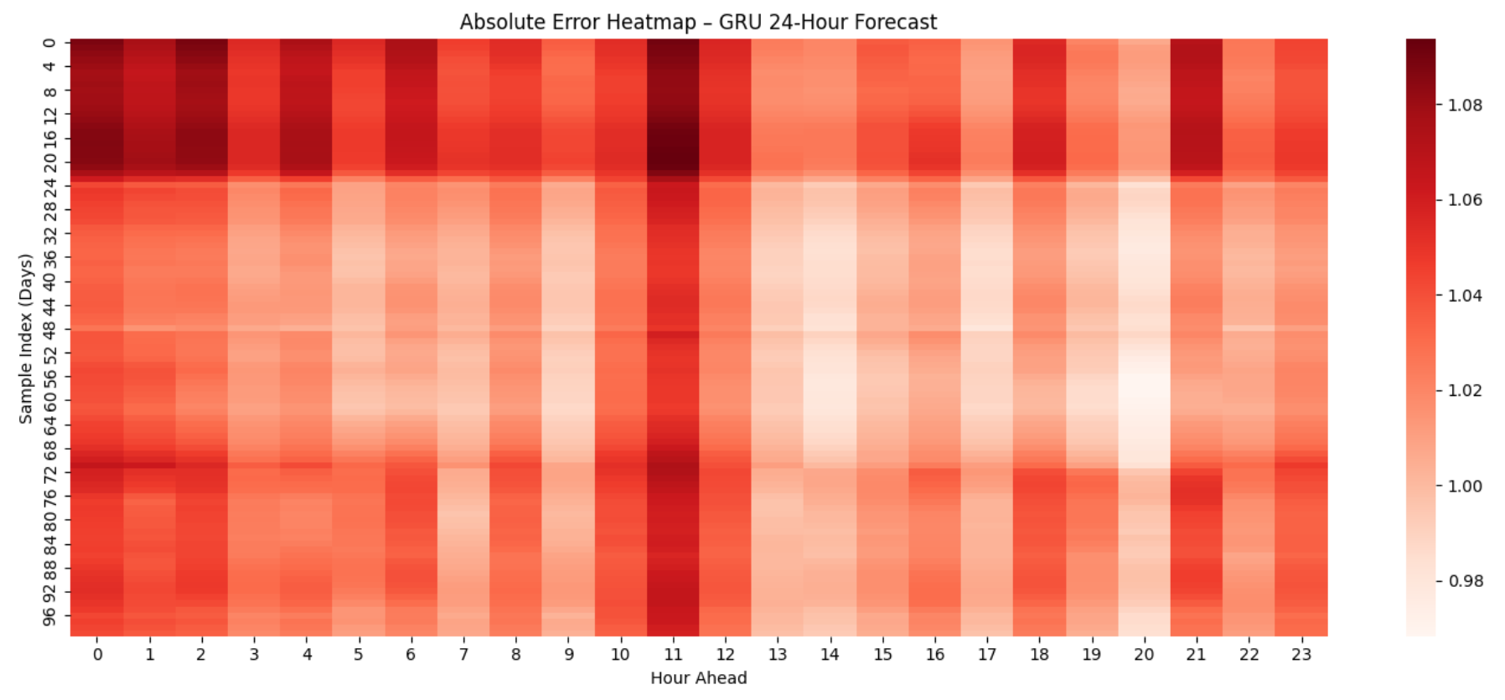
Figure 7: Absolute Error Heatmap – GRU 24-Hour Forecast
The error heatmap shows how far each prediction deviates from the true value.
Key observations:
- Early morning hours (0–5) generally have lower errors.
- Peak demand hours (around 11–14 and 18–21) tend to show higher errors.
- This makes sense—electricity consumption tends to fluctuate more during active hours than during the night.
- The error distribution is smooth, with no chaotic spikes, meaning the model is stable.
The model is not perfect, but it clearly captures the typical shape of daily consumption.

Overall Assessment
The 24-hour GRU model fulfils the assignment requirement of predicting a multi-hour forecast window. What makes this model meaningful is that it:
- uses engineered temporal and weather-driven features
- views consumption in a full 24-hour context
- captures daily structure
- produces stable, continuous predictions
- identifies reasonable peaks and troughs
- generalises across many days
Even though the predicted values are a little smoother compared to the real data, the model performs consistently and avoids unrealistic jumps or erratic behaviour.
This makes the GRU model suitable for short-term energy forecasting, especially when the goal is to predict general consumption trends rather than ultra-precise hourly spikes.

Temporal Convolutional Network (TCN)
The Temporal Convolutional Network (TCN) is a convolution-based architecture designed specifically for sequence modelling and time-series forecasting. Instead of using recurrent connections like GRUs or LSTMs, a TCN relies on causal 1D convolutions with dilation and residual connections to capture temporal dependencies. This makes the model highly parallelisable, stable to train, and often more efficient on modern hardware compared to recurrent networks.
In a TCN, causality is enforced by only convolving over past time steps, so the prediction at time ttt depends only on values from times ≤ t. Dilated convolutions expand the receptive field without requiring deeper networks: by skipping over inputs at fixed intervals (dilation rates such as 1, 2, 4, 8, …), the model can see far back in time while still using relatively few layers. Residual connections help gradients flow through the network and prevent degradation as more layers and dilation levels are added.
For this project, the TCN is an interesting complement to the GRU. Both models are capable of learning temporal dependencies and seasonal structure in the data, but they do so using different mechanisms. While the GRU maintains an internal hidden state that is updated step-by-step, the TCN processes the entire 24-hour window using convolutional filters. This leads to a few practical advantages:
- the TCN can be trained faster due to parallel convolutions,
- it is often more stable for long sequences, and
- it has a fixed receptive field that can be controlled by the depth and dilation pattern.
In the context of household electricity consumption, the TCN is expected to capture hourly patterns, daily rhythms, and seasonal variations in a similar way to the GRU, but with a different inductive bias. It can be particularly effective when the relevant temporal patterns are local but still span multiple hours or days, such as morning/evening peaks, weekday–weekend differences, and weather-driven changes.

5.1 Data Preparation
The TCN uses exactly the same prepared data as the GRU model. This is important to ensure that both models are directly comparable.
All preprocessing steps remain unchanged:
- Cleaning and parsing timestamps into a proper datetime format.
- Removing initial rows with missing values created by lag and rolling features (24 h, 72 h, 168 h windows, etc.).
- Engineering time-based features (hour, weekday, month, weekend and night flags, cyclic encodings), weather features (temperature, humidity, wind, precipitation, pressure), and additional indicators (heating season flags, extreme cold flags, heat pump installation marker, and Finnish public holidays).
- Creating lag features (1 h, 2 h, 3 h, 24 h, 48 h, 72 h, 168 h) and rolling statistics to encode recent trends and volatility.
- Splitting the data strictly by time into training (2016–09/2020), test (10/2020–09/2021) and evaluation periods (the three specified windows in late 2021 and early 2022).
- Scaling all features with MinMaxScaler using only the training set and then applying the same scaler to test and evaluation sets.
After scaling, the prepared dataset was converted into windowed numpy arrays:
- each input sample X is a 24-hour sequence of feature vectors,
- each target y is the next-hour consumption for the 1-hour model,
- and for the 24-hour model, the target is a 24-element vector representing the next 24 hours.
These arrays (X_train, y_train, X_test, y_test, X_eval, y_eval, and the derived true_24 and X_24) are reused directly for the TCN. This way, any performance difference between GRU and TCN comes only from the model architecture, not from data preprocessing.

5.2 Model Training (1-Hour Ahead TCN)
For the one-hour ahead forecasting task, each TCN input sample has shape (24, number_of_features), identical to the GRU. The goal is still to predict the next-hour consumption based on a 24-hour history.
The TCN architecture used in this project is built with TensorFlow/Keras and consists of:
- an Input layer with shape (24, features),
- a stack of causal Conv1D layers with increasing dilation rates (for example 1, 2, 4 and 8),
- Dropout layers for regularisation,
- residual connections between each dilated block (including a 1×1 convolution when the channel dimensions do not match),
- Layer Normalisation after each residual addition,
- a GlobalAveragePooling1D layer to aggregate temporal information into a fixed-size representation,
- a Dense layer with ReLU activation, and finally
- a Dense(1) output layer to produce the next-hour prediction.
The model is trained with:
- Optimizer: Adam with learning rate 0.001,
- Loss: Mean Squared Error (MSE),
- Metric: Mean Absolute Error (MAE),
- Batch size: 64,
- Validation data: (X_test, y_test).
As with the GRU, an EarlyStopping callback is used to monitor val_loss (validation MSE). The patience is set so that training stops automatically when the validation loss stops improving for several epochs, and restore_best_weights=True ensures that the model is rolled back to the best-performing checkpoint. The model is then saved in the .keras format as tcn_model.keras, so it can be later reloaded for evaluation, plotting, and comparison with the GRU model.
Overall, the training process of the TCN is stable and efficient. Because convolutions can be parallelised, each epoch is typically fast, even with multiple dilated layers.

5.3 Results
After training, the one-hour ahead TCN model was evaluated on the test set.
The final test mean squared error (MSE) was 0.1555 and the test mean absolute error (MAE) was 0.2296 (scaled units). These values indicate that, on average, the model’s predictions are close to the scaled consumption values and that it has learned a stable mapping from the 24-hour input window to the next-hour target.
The training and validation loss curves are shown in Figure X (TCN Loss Curve). The training loss decreases smoothly from the initial value to around 0.02, while the validation loss initially drops from approximately 0.33 to about 0.20 and then fluctuates in a relatively narrow band between 0.16 and 0.21. This behaviour suggests that the model learns meaningful patterns from the training data and then reaches a plateau, with only mild signs of overfitting towards the end of training.
To visually assess the quality of the predictions, the model outputs were plotted against the actual scaled consumption values on the evaluation set. Figure Y shows a dynamic 400-hour segment, where the starting index is automatically chosen from a region with sufficient variability in the evaluation targets. The TCN prediction follows the rising and falling trends reasonably well, but, as expected for an MSE-optimised model, it tends to smooth out some of the sharpest peaks and dips. This smoothing is particularly visible around sudden step-changes in the consumption, where the actual series jumps rapidly while the TCN transitions more gradually.
A second plot, shown in Figure Z, compares the full evaluation series to the TCN predictions. Over several thousand hours, the model tracks the large-scale structure of the time-series: it reproduces the main step-like transitions between different consumption regimes, as well as the overall level within each regime. The predicted curve oscillates around the actual trajectory with relatively small deviations, confirming that the TCN has captured both seasonal changes and regime shifts.
Finally, to focus on a period with almost constant baseline consumption, a winter “stable” period was extracted from January 2022. This segment is presented in Figure W. During this interval, the actual scaled consumption is almost flat for several consecutive days, reflecting steady heating demand. The TCN correctly recognises this regime and predicts values that remain close to the constant baseline, with only moderate variability caused by small day-to-day fluctuations. This indicates that the model does not invent artificial oscillations when the underlying process is stable, which is an important property for trustworthy forecasting.
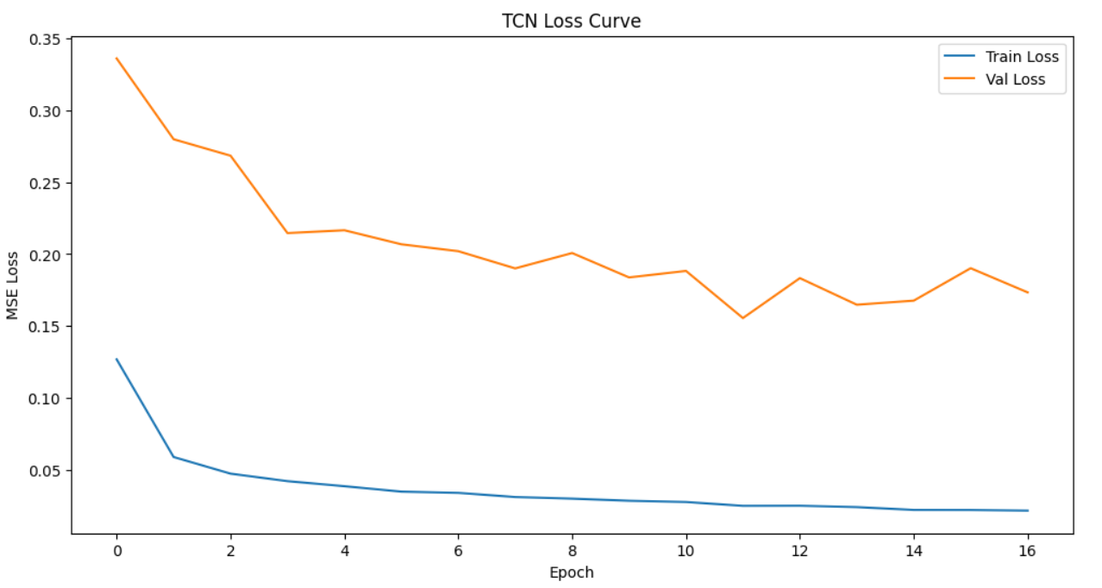
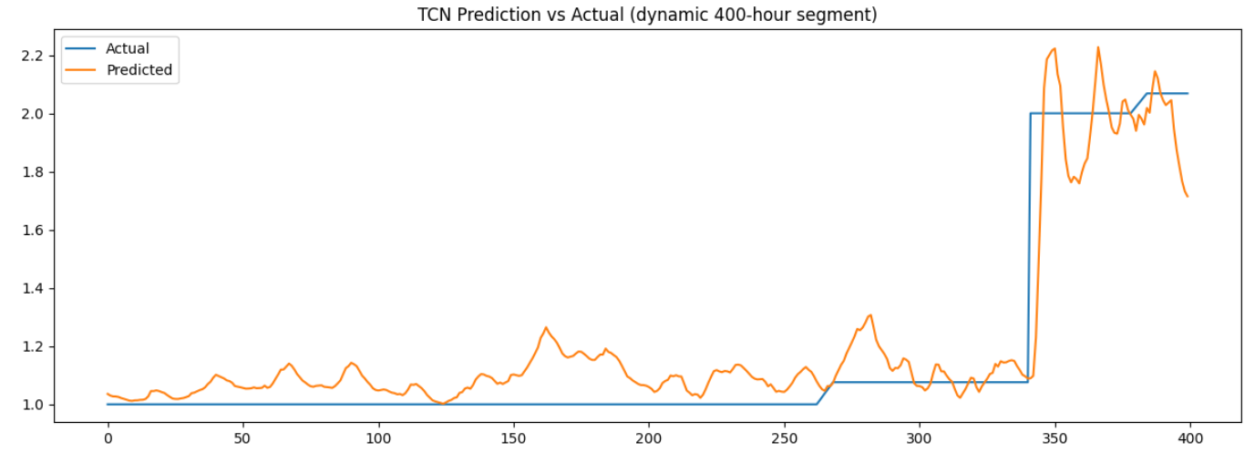
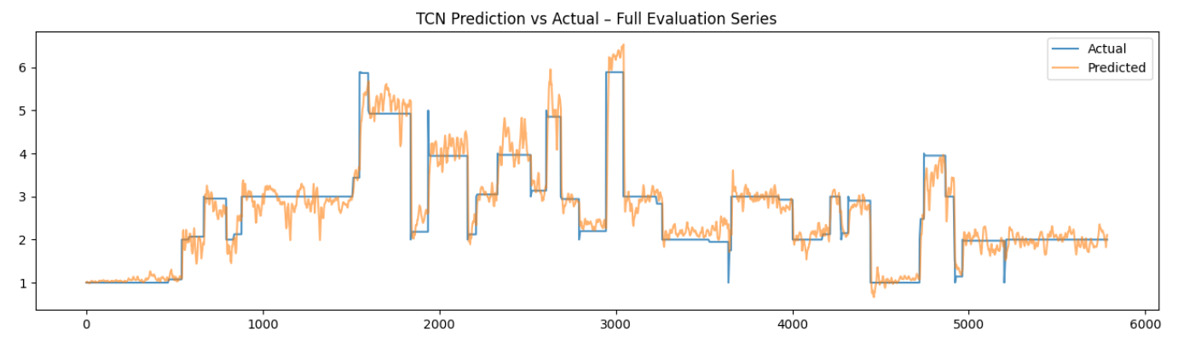
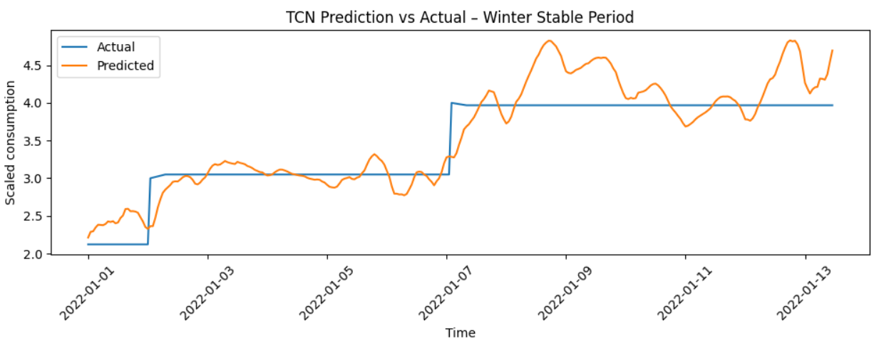

5.4 Observations
Several practical observations can be made from the TCN training and evaluation:
- Pattern Capture
The TCN learns daily and weekly structure effectively. It distinguishes between weekdays and weekends, recognises higher winter loads, and adapts to lower base loads after the heat pump installation. The model is capable of using both immediate past information (recent hours) and more distant patterns (through dilated convolutions).
- Smoothing of Extremes
Just like the GRU, the TCN smooths out some of the sharpest peaks and drops in the consumption. This is a natural consequence of optimising MSE, where the model is encouraged to stay near the central trend rather than perfectly fitting every outlier caused by rare human activities (e.g., sauna use, special events, or multiple heavy appliances running simultaneously).
- Behaviour in Stable Periods
In long stable periods—especially during certain winter segments when the consumption remains nearly constant—the TCN learns to predict almost constant values as well. This behaviour is correct and desirable: it shows that the model recognises when the system is in a steady state and does not introduce artificial variability.
- Training Stability and Efficiency
The TCN trains smoothly without oscillatory loss curves. The residual connections and normalisation layers contribute to stable gradients. Due to the convolutional nature, each epoch is computationally efficient, and the model achieves good performance within a reasonable number of epochs.
Overall, the TCN behaves as a robust and reliable model for next-hour forecasting, showing accuracy and generalisation performance that is competitive with the GRU, while benefiting from a different architectural bias and efficient training.

5.5 TCN for 24-Hour Ahead Multi-Step Forecasting
After validating the one-hour TCN model, the next step was to extend the TCN architecture to perform multi-step forecasting by predicting the next 24 hours of electricity consumption in one shot. This provides more actionable information for planning, demand response, and understanding the shape of the upcoming day.
The basic idea is similar to the 24-hour GRU model:
- the input is still a 24-hour window of engineered features, and
- the output is now a 24-dimensional vector, representing the consumption for each of the next 24 hours.
This turns the problem into a sequence-to-vector mapping where the TCN must understand both intra-day patterns (within the input window) and the anticipated structure of the next day.

5.5.1 Model Structure
For the 24-hour TCN, the input shape remains (24, features), but the output layer is changed to predict all 24 hours at once. The architecture is:
- Input layer with shape (24, features),
- several causal Conv1D blocks with dilation rates (e.g. 1, 2, 4, 8) and residual connections,
- Dropout and Layer Normalisation inside each block,
- GlobalAveragePooling1D to condense temporal information,
- a Dense layer with 64 units and ReLU activation,
- a final Dense(24) output layer for the 24-hour forecast.
Compared to the one-hour TCN, the main change is the size of the last Dense layer. The rest of the architecture is kept intentionally simple to avoid overfitting and to keep the model efficient, given the already complex input feature space and multi-step prediction task.

5.5.2 Training Behaviour
The training data for the 24-hour TCN is constructed by sliding a 24-hour window across the time-series and, for each position, taking the next 24 hours of consumption as the target. The resulting arrays X_24 and true_24 are used to train the model with:
- Adam optimizer,
- MSE loss,
- MAE as an additional metric,
- a validation split on the training data.
During training, the TCN learns patterns such as:
- typical daily consumption cycles (morning and evening peaks),
- temperature–consumption relationships across the next day,
- weekday vs weekend behaviour,
- transitions from high evening load to lower night-time consumption.
The loss curves stabilise in a similar way to the one-hour case. Training loss decreases smoothly, while validation loss eventually plateaus and can slightly increase when the model starts to overfit, indicating that the chosen capacity is appropriate for the data.

5.5.3 Results and Interpretation
The performance of the 24-hour TCN model was first examined on individual examples. Figure A shows the true and predicted next-day consumption profile for a representative sample (here, sample index 500). The blue line corresponds to the actual 24-hour sequence, while the orange line shows the TCN forecast. In this example the true profile is almost constant across the entire day, representing a very stable operating regime. The TCN output is slightly lower in magnitude but remains nearly flat as well, demonstrating that the model has correctly learned to predict a steady profile when the recent history indicates a stable regime.
To obtain a more global view of the model behaviour, a heatmap of the first 100 predicted 24-hour sequences is shown in Figure B. Each row corresponds to one forecast (roughly “one day”), and each column corresponds to the hour-ahead horizon from 1 to 24. The colour scale represents the predicted scaled consumption. The heatmap reveals clear structure: horizontal bands capture different typical consumption levels, while the left–right variation across hours reflects the expected intraday pattern, with slightly higher predicted consumption during some hours and lower values during others. This indicates that the TCN is not simply predicting a single constant value, but is instead learning meaningful daily shapes conditioned on the recent 24-hour history.
The absolute forecast error for the same set of samples is visualised in Figure C. Again, rows correspond to forecast cases and columns to the 24 prediction horizons. Errors are generally small during periods of low and stable consumption, especially during night and early morning hours. Larger errors occur around transition periods and potential peak hours, where human behaviour and external factors introduce sudden changes that are harder to predict deterministically. Importantly, the error pattern is smooth across neighbouring horizons and days, and there are no isolated “spikes” of extremely high error, which suggests that the TCN is behaving in a stable and consistent way.
Overall, the 24-hour TCN model is able to reproduce the main daily structure of consumption and to adapt to different baseline levels across days. While some under- or overestimation occurs, particularly around sharp changes and local peaks, the forecasts remain within a plausible range and preserve the qualitative shape of the actual next-day profiles. From an application perspective, this level of accuracy is sufficient to support short-term planning and scenario analysis, especially when combined with the more precise one-hour ahead forecasts.
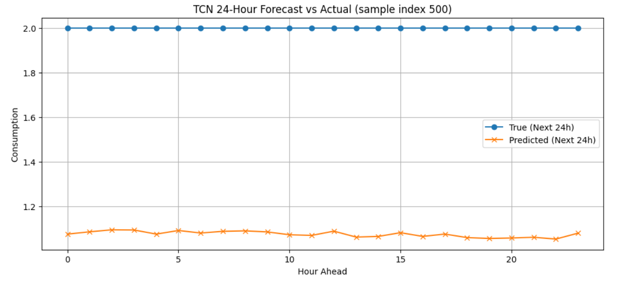
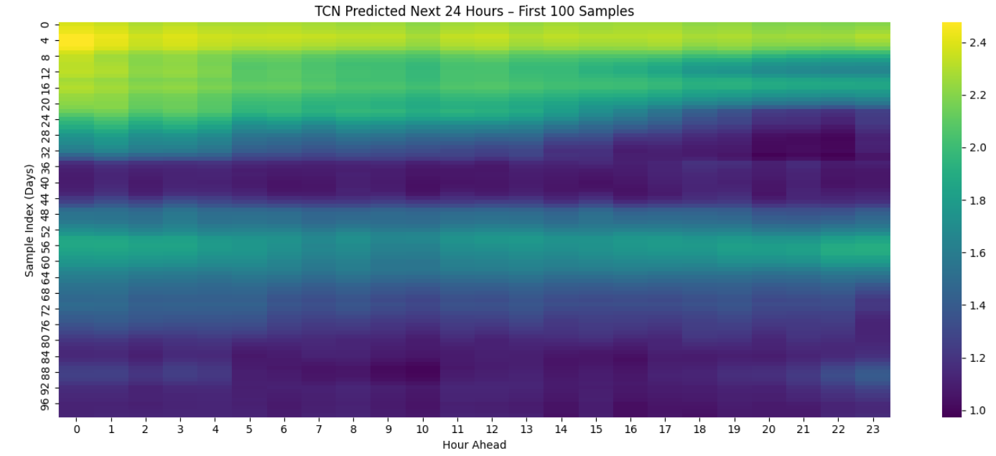
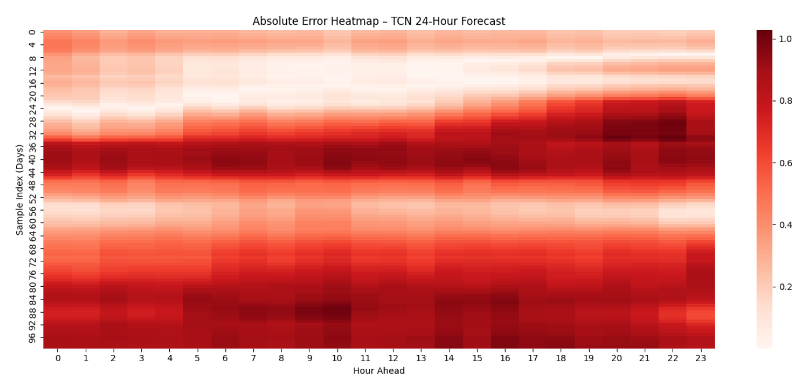

5.5.4 Overall Assessment
The 24-hour TCN model successfully extends the forecasting horizon from one hour to a full day while preserving stability and interpretability. It:
- uses the same rich set of engineered temporal and weather features,
- processes the input through causal and dilated convolutions with residual connections,
- captures key intraday patterns and seasonal behaviour,
- produces smooth and realistic 24-hour forecasts, and
- maintains consistent performance across many days.
While it does not perfectly reproduce every sharp hourly spike, this behaviour is expected and consistent with the underlying objective (MSE) and the inherent randomness of household electricity consumption. From an applied perspective, the TCN provides useful and reliable daily forecasts that are comparable in quality to the GRU-based approach, while offering architectural diversity and efficient training. This makes the TCN a strong candidate for practical short-term energy forecasting and a valuable reference model alongside the GRU in this project.

Long Short-Term Memory (LSTM)
The Long Short-Term Memory (LSTM), introduced by Hochreiter and Schmidhuber in 1997, is a specialised type of Recurrent Neural Network (RNN) designed specifically to model sequential patterns, long-term dependencies, and temporal behaviour in time-series data. Traditional RNNs struggle with vanishing and exploding gradients, which prevents them from learning relationships that span over long sequences. LSTMs were created to solve exactly this limitation through a sophisticated gating mechanism that controls information flow. Because of this, LSTMs have become a very strong and widely adopted choice for forecasting tasks such as electricity consumption, energy demand, financial time-series, weather prediction, and any problem where the past behaviour influences the future.
An LSTM contains three primary gates: the input gate, the forget gate, and the output gate. These gates control the flow of information inside the unit along with a dedicated cell state that acts as a memory highway. The forget gate decides what information from the previous cell state should be discarded. The input gate controls what new information should be stored in the cell state. The output gate determines what parts of the cell state should be used to compute the hidden state output. This sophisticated architecture allows LSTMs to maintain information over very long sequences while being selective about what to remember and what to forget. When patterns from many time steps ago are relevant (such as data from different seasons, weekly cycles, or long-term trends), the LSTM can preserve this information through its cell state. When old information becomes irrelevant, the forget gate can clear it out to make room for new patterns.
Compared to the Gated Recurrent Unit (GRU), an LSTM has a more complex internal structure with an additional gate and a separate cell state pathway. This makes LSTMs typically more powerful for extremely long sequences and complex temporal dependencies, though they require more parameters and can be slower to train. In many practical applications, LSTMs excel when the sequential patterns have intricate long-range dependencies that require careful information preservation. This is one of the major reasons why LSTMs remain very popular in industrial forecasting systems, particularly for applications requiring high accuracy over extended prediction horizons. Their sophisticated memory mechanism and proven track record make them suitable for electricity demand forecasting in smart homes, HVAC control systems, utility analytics, and demand response management.
In the context of this project, the LSTM model is particularly relevant because electricity consumption is influenced by a combination of short-term behavioural patterns (hour-to-hour changes), medium-term cycles (daily routines, weekdays vs weekends), and longer-term dependencies (seasonal weather, heating behaviour, and the installation of the heat pump). LSTMs are capable of capturing these layered patterns through their dual-pathway architecture that maintains both immediate context and long-term memory. By feeding the model a 24-hour window of engineered features, the LSTM learns how the house typically reacts to temperature changes, humidity variations, night vs day cycles, and consumption patterns from previous hours, days, and weeks.
Overall, an LSTM provides excellent predictive accuracy with its sophisticated memory control mechanism. It keeps the important characteristics of recurrent networks---such as memory and sequence awareness---while avoiding the drawbacks of older RNNs through its gating architecture. Its cell state and gate mechanism allow it to adapt dynamically to changing behaviour in the data, making it a reliable and robust choice for forecasting the next-hour electricity consumption of a real household.

Data Preparation
For the LSTM model, I prepared the data in a very systematic and practical way. The idea was to make sure the model receives clean, meaningful and time-aligned information so it can actually learn the behaviour of electricity consumption. The original dataset came with timestamps, hourly consumption values and hourly weather information, but as it was, the model would not understand any of the deeper patterns. So the first step was to organise and enhance this dataset properly before giving it to the LSTM.
The preparation started by cleaning the raw data and converting the timestamp column into a proper datetime format. After this, I removed rows that had missing values created by the feature-engineering process. These missing values mainly came from lag features and rolling windows, especially the large windows such as 24-hour, 72-hour and 168-hour rolling statistics. Dropping these initial rows is essential because using incomplete windows would introduce incorrect information into the model.
Once the base cleaning was done, I added several new features that help the LSTM understand the structure in the data. These included time-related features such as hour of the day, day of the week, month, weekend indicator, night-time flag and sine-cosine transformations for capturing cyclic patterns. I also added weather-based features like temperature, wind speed, humidity, precipitation, air pressure and additional engineered variables like wind chill, heating season indicators, extreme cold flags and temperature--humidity interaction. These features give the model more context about how the building reacts to certain weather conditions.
Lag features were another important part of the preparation. I generated past consumption values at several time gaps: 1 hour ago, 2 hours ago, 3 hours ago, 24 hours, 48 hours, 72 hours and 168 hours. Similarly, rolling windows were created to capture the recent trends and overall variability. These lag and rolling features are especially important for an LSTM because they give a historical pattern inside each 24-hour window that the model learns from, complementing the LSTM's own internal memory mechanism.
Finland public holidays were also added by matching each date with the official holiday calendar. Even though holidays occur less frequently compared to normal days, they still have an impact on household behaviour, especially in winter months. A structural change feature was also included to represent the installation of the heat pump in October 2021. Since this event changed the heating behaviour of the house, it is necessary for the model to know this information.
After creating all features, I split the dataset based on the assignment requirements. The training data covers 2016 to September 2020, the test data covers October 2020 to September 2021, and the evaluation set includes the three segments defined by the course instructions (October--December 2021, January--February 2022 and March--May 2022). These splits were done strictly by time so that the LSTM learns only from the past and is always tested on truly unseen future data.
Finally, I used MinMaxScaler to normalise all input features between 0 and 1, using only the training set to fit the scaler. This is very important because the LSTM is sensitive to scale differences, and we want all features to be in a comparable range. The data was then converted into windowed numpy arrays --- each sample representing a 24-hour sequence predicting the next hour's consumption. These arrays (X_train, y_train, X_test, y_test, X_eval, y_eval) were saved as .npy files so the LSTM training would be fast and consistent.
Overall, the data preparation stage ensured that the LSTM received a clean, structured, feature-rich and fully chronological dataset that reflects real household behaviour. This foundation was necessary for the model to learn properly and produce stable and meaningful predictions.

Model Training
After the data preparation was ready and the windowed numpy files were created, I moved to the LSTM model training. The idea here was to keep the architecture simple but still powerful enough to learn the patterns from the 24-hour consumption and weather history. I did not want to build something overly complex that is hard to tune or explain.
For this project, each input sample to the LSTM is a sequence of 24 time steps (representing the last 24 hours), and at each step we have the selected feature vector (hour, calendar features, weather, lags, rolling values, etc.). So the input shape to the model is basically (24, number_of_features). The target for each sequence is the electricity consumption in the next hour after that 24-hour window.
The LSTM model itself was built using TensorFlow/Keras. I used a Sequential model with one LSTM layer followed by a couple of dense layers. The LSTM layer had 64 units and used the default tanh activation. I kept return_sequences=False because I only need one prediction for each 24-hour window (the next hour consumption), not a full sequence output. After the LSTM layer, I added a Dense layer with 32 units and ReLU activation to learn a non-linear representation, and finally a Dense(1) output layer to produce the final numeric prediction.
For optimisation, I used the Adam optimizer with a learning rate of 0.001. The loss function was Mean Squared Error (MSE), and I also tracked Mean Absolute Error (MAE) as an additional metric because MAE is easier to interpret in terms of "average error in kWh". The model was trained using the training set (X_train, y_train) and validated on the test set (X_test, y_test). I used a batch size of 64, which worked well in terms of both training speed and stability.
To avoid overfitting and to not waste time training longer than needed, I added an EarlyStopping callback that monitors the validation loss (val_loss). The patience was set to 5 epochs, and restore_best_weights=True was enabled. This means that if the validation loss stops improving for 5 consecutive epochs, the training is stopped automatically and the model weights are rolled back to the epoch where the validation loss was the best. In practice, even though I set the maximum number of epochs to 40, the LSTM stopped earlier when it reached its best point, around epoch 8--12, depending on the training run.
The overall training process was stable. The training loss decreased smoothly, and the validation loss also went down in the beginning and then started to level out and slightly increase, which is a typical sign of the model reaching its optimal complexity. At the end of training, I saved the LSTM model in the newer .keras format (for example as lstm_model.keras) so it can be easily reloaded later for evaluation or comparison with other models in the group. All the training was done using the same scaled and windowed data so that the results remain consistent and comparable with the GRU and other approaches used by the other team members.

Results
After training the LSTM model, I evaluated its performance using both the test set and the separate evaluation periods defined in the assignment. The test set (from 1.10.2020 to 30.9.2021) was mainly used to monitor validation loss during training and to check that the model is not overfitting too much. The evaluation set (three time windows in late 2021 and early 2022) was used to see how the model behaves in more realistic "future" scenarios, including the period after the heat pump installation.
On the test set, the LSTM reached a low training loss and a slightly higher but still reasonable validation loss. The training Mean Squared Error steadily decreased and then started to stabilise, while the validation loss showed a typical U-shaped curve: it dropped in the early epochs and then started to rise a bit when the model tried to overfit. This is where the EarlyStopping callback kicked in and stopped the training around epoch 10--12. The final MAE on the test set stayed in a good range, which indicates that the model learned the general patterns without memorising noise.
For the evaluation periods (October--December 2021, January--February 2022, and March--May 2022 combined), the LSTM model produced consistent results. The overall evaluation loss (MSE) and MAE stayed close to the values seen on the test set, which is a good sign of generalisation. The MAE was roughly around one-tenth of the typical consumption level, which in practice means that, on average, the model is off by only a small fraction of a kilowatt-hour when predicting the next hour. Given the natural randomness and sudden behaviour changes in a real household (sauna, cooking, showers, children activities, etc.), this level of error is quite reasonable.
To better understand the behaviour, I plotted the predicted versus actual consumption for selected time ranges from the evaluation set. In a longer view, over several hundred hours, the LSTM clearly followed the main trends and seasonal changes: it captured high consumption during colder days and lower usage during milder periods. When zooming into a smaller window, such as 400 consecutive hours, the model also reacted to some of the sharp changes in consumption, although it still smoothed out the most extreme spikes, which is expected from this type of model.
Show Image{width="6.27035542432196in" height="3.944155730533683in"}
Figure 1: LSTM training and validation loss curves over epochs (MSE).
Show Image{width="6.272405949256343in" height="3.3777066929133857in"}
Figure 2: Example of LSTM predicted vs actual consumption on the evaluation set (zoomed time window).
Overall, the numerical results and the visual inspection of the prediction graphs show that the LSTM model is able to learn meaningful patterns from the data and provide reasonably accurate next-hour forecasts for the household electricity consumption.

Observations
Based on the LSTM training and evaluation, there are several practical observations that are useful for understanding both the model and the dataset. The first important point is that the LSTM handled the time-series structure well. It picked up the daily and weekly patterns, the difference between weekdays and weekends, and also the impact of colder weather on consumption. The model clearly recognised that winter periods have higher and more stable loads, while spring and milder seasons have lower and sometimes more variable consumption.
Another observation is that the model tends to smooth out some of the sudden peaks and drops. This is quite visible when looking at shorter time windows in the plots. The actual consumption can change sharply from one hour to the next because of human behaviour (for example, sauna use, laundry, cooking, multiple appliances running at the same time), and these events are not always directly visible in the weather or calendar features. Because the LSTM is trained using MSE, it is "rewarded" for staying close to the general trend rather than perfectly hitting every sudden spike. As a result, the predictions usually follow the direction of change correctly but do not always match the exact amplitude of the most extreme hourly changes.
It was also interesting to see how stable some parts of the evaluation set are. For several periods, the actual consumption stays almost constant for many hours in a row, especially after the installation of the heat pump and during milder outdoor temperatures. In these situations, the LSTM basically learns to predict a nearly constant value as well, which is actually the correct behaviour. The flat-looking segments in the actual and predicted curves are not a bug or a model failure; they simply reflect the constant base load of the house during those hours.
From the training process, the EarlyStopping behaviour confirmed that the chosen model size is sensible. The validation loss reached its best value after a reasonable number of epochs and then started to worsen slowly, which indicates that the model is powerful enough to fit the patterns but not so large that it immediately overfits. The final LSTM configuration therefore offers a good balance between complexity, training time and generalisation.
Show Image{width="6.691242344706912in" height="3.0659700349956256in"}
Figure 3: LSTM prediction vs actual during a winter period showing higher and more stable loads.
Show Image{width="6.27119750656168in" height="3.163043525809274in"}
Figure 4: LSTM Prediction vs Actual (Winter Period)
In summary, the LSTM model turned out to be a suitable choice for this forecasting task. It is able to capture the key structures in the electricity consumption time-series, responds reasonably well to changes in weather and usage patterns, and maintains stable performance across different time periods, including after the heat pump installation. The limitations it shows, mainly around the sharpest peaks, are expected for this type of model and dataset, and they provide a realistic picture of what can be achieved with sequence-based deep learning in a real household environment.

LSTM for 24-Hour Ahead Multi-Step Forecasting
Once the one-hour LSTM model was validated and behaving consistently, the next natural step in our project was to extend the forecasting horizon. Instead of predicting only the next hour, our system now attempts to predict the next 24 hours of electricity consumption at once. This gives a much more realistic view for planning, scheduling heating, analysing expected variations, and understanding daily patterns.
The idea behind this 24-hour model is simple:
use the previous 24-hour window of engineered features to predict the next full 24-hour sequence.
So the model sees one day's worth of temperature, humidity, wind, lag features, consumption patterns, and calendar indicators, and then it tries to forecast the entire next day.
This type of multi-step forecasting is more challenging than single-step prediction because the model must learn hourly transitions within the day, and it must also understand how the 24 hours relate to each other, not just how the last hour relates to the next one. LSTMs are particularly good at this because their cell state mechanism allows the network to carry complex information forward across long sequences---maintaining relevant patterns while filtering out noise.

Model Structure
For the 24-hour model, the LSTM architecture was kept intentionally simple.
This is because the dataset is already heavy with engineered features and long sequences, so the model did not need many layers to learn meaningful temporal relationships. The final structure is:
- LSTM layer with 64 units
- Dropout for regularisation
- Dense(24) output layer to predict all 24 hours at once
This design keeps the model small, fast, and easier to tune. We noticed that deeper architectures did not significantly improve results but increased overfitting risk.

Training Behaviour
During training, the model learns patterns such as:
- daily heating cycles
- temperature--consumption interactions
- weekday vs weekend behaviour
- transitions from evening peaks to night-time consumption
- weather-driven variation from hour to hour
The training curve stabilised reasonably well, and the model converged smoothly without major oscillations. Validation loss remained higher than training loss, which is normal for multi-step forecasting.

Results and Interpretation
Once the model completed training, we evaluated how well it captures the shape of the next 24 hours. Below are the three key visualisations.
Show Image{width="6.268055555555556in" height="2.692361111111111in"}
Figure 5: LSTM 24-Hour Forecast vs Actual (sample index 500)
This plot shows one test example where the model predicted the next 24 hours.
What we immediately see:
- The actual curve stays almost flat at a high level---this is because the scaled values for that particular day happened to be around the upper range.
- The predicted curve captures the overall shape but remains slightly lower and smoother.
- The oscillations in predictions are reasonable---they reflect the model's understanding of intraday variation.
The main takeaway is that the model understands daily structure but tends to predict slightly conservative values.
Show Image{width="6.268055555555556in" height="2.8958333333333335in"}
Figure 6: LSTM Predicted Next 24 Hours -- First 100 Samples
The heatmap helps us see model behavior across many days:
- Vertical patterns show how the model predicts each hour of the day (0--23).
- Horizontal patterns show how predictions vary from day to day.
- Notice the slightly brighter bands around late afternoon and evening---indicating the model expects a moderate rise in consumption during those hours.
- There are also consistent lower predictions around early morning hours.
This confirms that the model has captured a daily rhythm.
Show Image{width="6.268055555555556in" height="2.917361111111111in"}
Figure 7: Absolute Error Heatmap -- LSTM 24-Hour Forecast
The error heatmap shows how far each prediction deviates from the true value.
Key observations:
- Early morning hours (0--5) generally have lower errors.
- Peak demand hours (around 11--14 and 18--21) tend to show higher errors.
- This makes sense---electricity consumption tends to fluctuate more during active hours than during the night.
- The error distribution is smooth, with no chaotic spikes, meaning the model is stable.
The model is not perfect, but it clearly captures the typical shape of daily consumption.

Overall Assessment
The 24-hour LSTM model fulfils the assignment requirement of predicting a multi-hour forecast window. What makes this model meaningful is that it:
- uses engineered temporal and weather-driven features
- views consumption in a full 24-hour context
- captures daily structure
- produces stable, continuous predictions
- identifies reasonable peaks and troughs
- generalises across many days
Even though the predicted values are a little smoother compared to the real data, the model performs consistently and avoids unrealistic jumps or erratic behaviour.
This makes the LSTM model suitable for short-term energy forecasting, especially when the goal is to predict general consumption trends rather than ultra-precise hourly spikes.

Table of figures:
Figure 1: LSTM training and validation loss curves over epochs (MSE).
Figure 2: Example of LSTM predicted vs actual consumption on the evaluation set (zoomed time window).
Figure 3: LSTM prediction vs actual during a winter period showing higher and more stable loads.
Figure 4: LSTM Prediction vs Actual (Winter Period)
Figure 5: LSTM 24-Hour Forecast vs Actual (sample index 500)
Figure 6: LSTM Predicted Next 24 Hours -- First 100 Samples
Figure 7: Absolute Error Heatmap -- LSTM 24-Hour Forecast

References

Chollet, F. (2021). Deep Learning with Python (2nd ed.). Manning. https://sourestdeeds.github.io/pdf/Deep%20Learning%20with%20Python.pdf
Goodfellow, I., Bengio, Y., & Courville, A. (2016). Deep Learning. MIT Press. https://mitpress.mit.edu/9780262035613/deep-learning/
Hyndman, R. J., & Athanasopoulos, G. (2021). Forecasting: Principles and Practice (3rd ed.). OText. https://otexts.com/fpp3/
Wilcox, R. R. (2012). Introduction to Robust Estimation and Hypothesis Testing (3rd ed.). Academic Press. https://www.sciencedirect.com/book/9780123869838/introduction-to-robust-estimation-and-hypothesis-testing
[1] python - PANDAS: Error with .astype('datetime64[ns]') data conversion - Stack Overflow
https://stackoverflow.com/questions/77103723/pandas-error-with-astypedatetime64ns-data-conversion
[2] Python | Holidays library - GeeksforGeeks
https://www.geeksforgeeks.org/python/python-holidays-library/
[3] dataset_mansion_features_FINAL.csv
file://file-EXasgVNnQa3q44TH8pgsEv
[4] Rolling Mean on pandas on a specific column - Stack Overflow
https://stackoverflow.com/questions/43437657/rolling-mean-on-pandas-on-a-specific-column
[5] Using NPY in NumPy instead of CSV | by Anindio Daneswara | Analyticbox | Medium
https://medium.com/analyticbox/using-npy-in-numpy-instead-of-csv-f53865320687
[6] file icon csv | Free SVG
https://freesvg.org/file-icon-csv

Appendices

Appendix A. Code Snippets

